# Session 1:

Tasks 1:
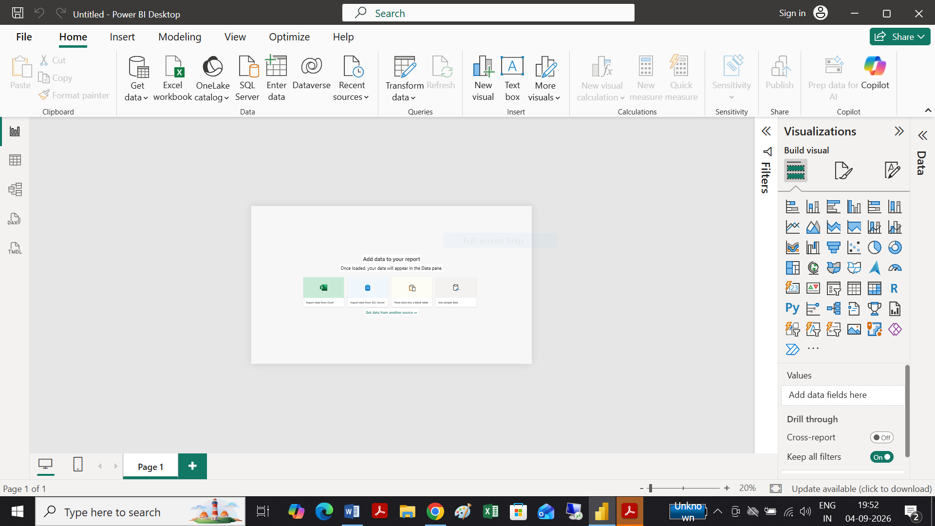

Tasks 2:

Power BI Desktop Interface Components
Component | Short Description
1. Report View | Used to create and design interactive reports and dashboards. You can add charts, tables, cards, slicers, and other visuals here.
2. Data View | Displays the actual data stored in your tables. It allows you to inspect, sort, and work with individual rows and columns of data.
3. Model View | Shows the relationships between different tables in the data model. It is used to create and manage relationships between tables.
4. Fields Pane | Lists all the tables, columns, and measures available in the data model. You can drag these fields onto visuals to build reports.
5. Visualizations Pane | Contains tools for creating and formatting visualizations such as bar charts, pie charts, tables, and graphs. It also provides formatting options for selected visuals.
6. Filters Pane | Allows you to filter the data displayed in a report or visual. Filters can be applied to a specific visual, an entire page, or the whole report
Tasks 3:
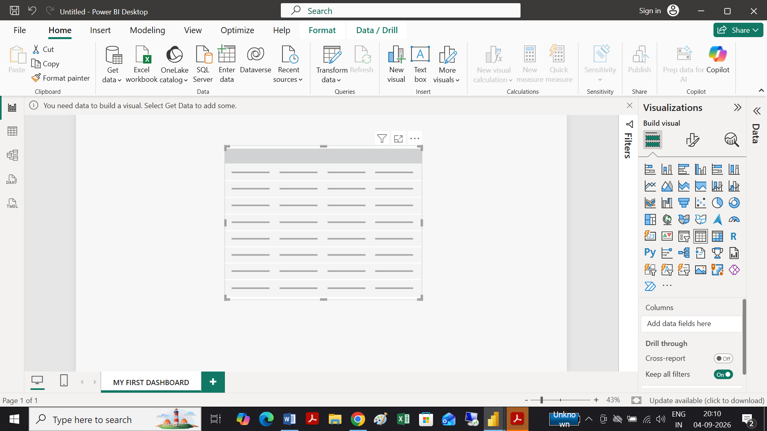

Excel Dashboard | Power BI Dashboard
1. Data & Analysis: Mainly uses worksheets, formulas, PivotTables, and PivotCharts for analysis. | 1. Data & Analysis: Designed for connecting, transforming, and analyzing data from multiple sources using Power Query and DAX.
2. Visualization: Uses charts, tables, slicers, and other Excel objects that are arranged manually on a worksheet. | 2. Visualization: Provides interactive visuals, filters, slicers, and a dedicated Visualizations pane for creating and formatting reports.
3. Workflow & Sharing: Dashboards are generally maintained within Excel workbooks and shared as files. | 3. Workflow & Sharing: Reports can be published to Power BI Service, where dashboards can be shared and viewed interactively across devices.
Tasks 4:
Here are 3 key differences between Excel Dashboards and PowerBI Dashboards:
# Session 2:
Tasks 1:
Report View:
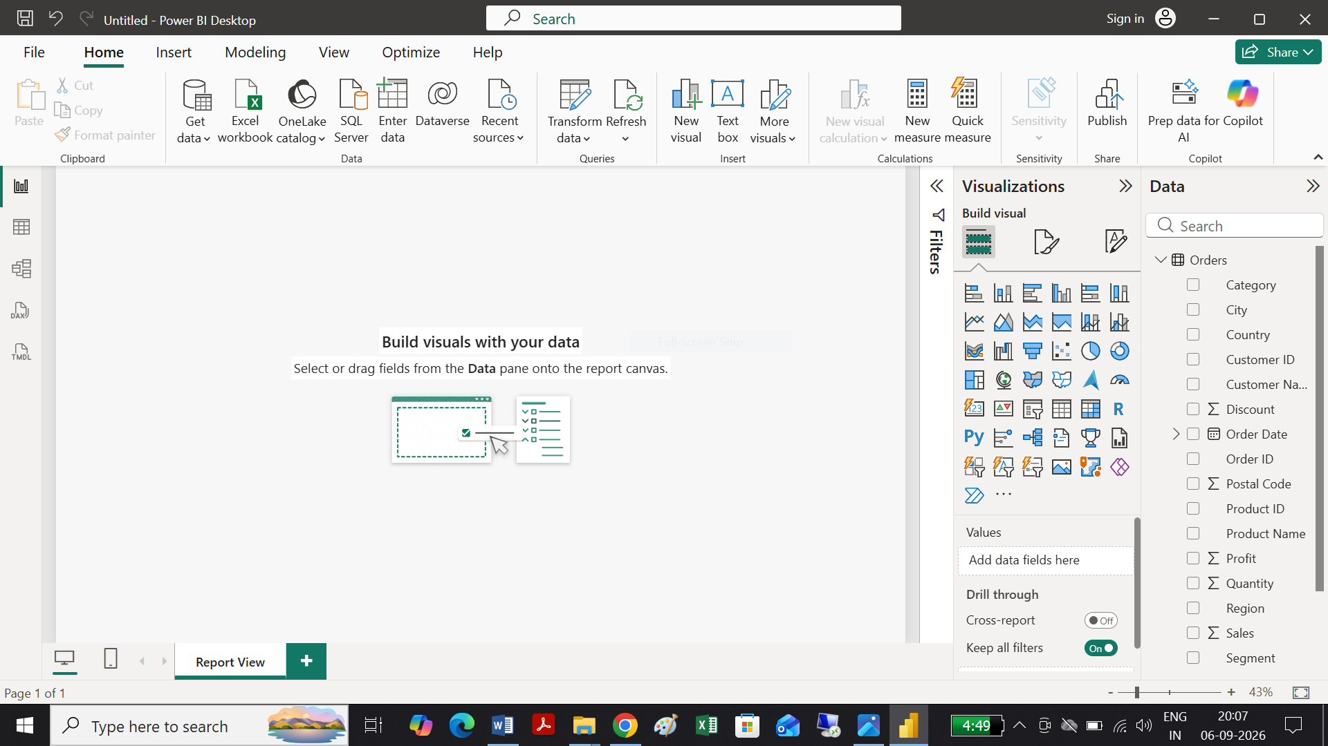

Table View:
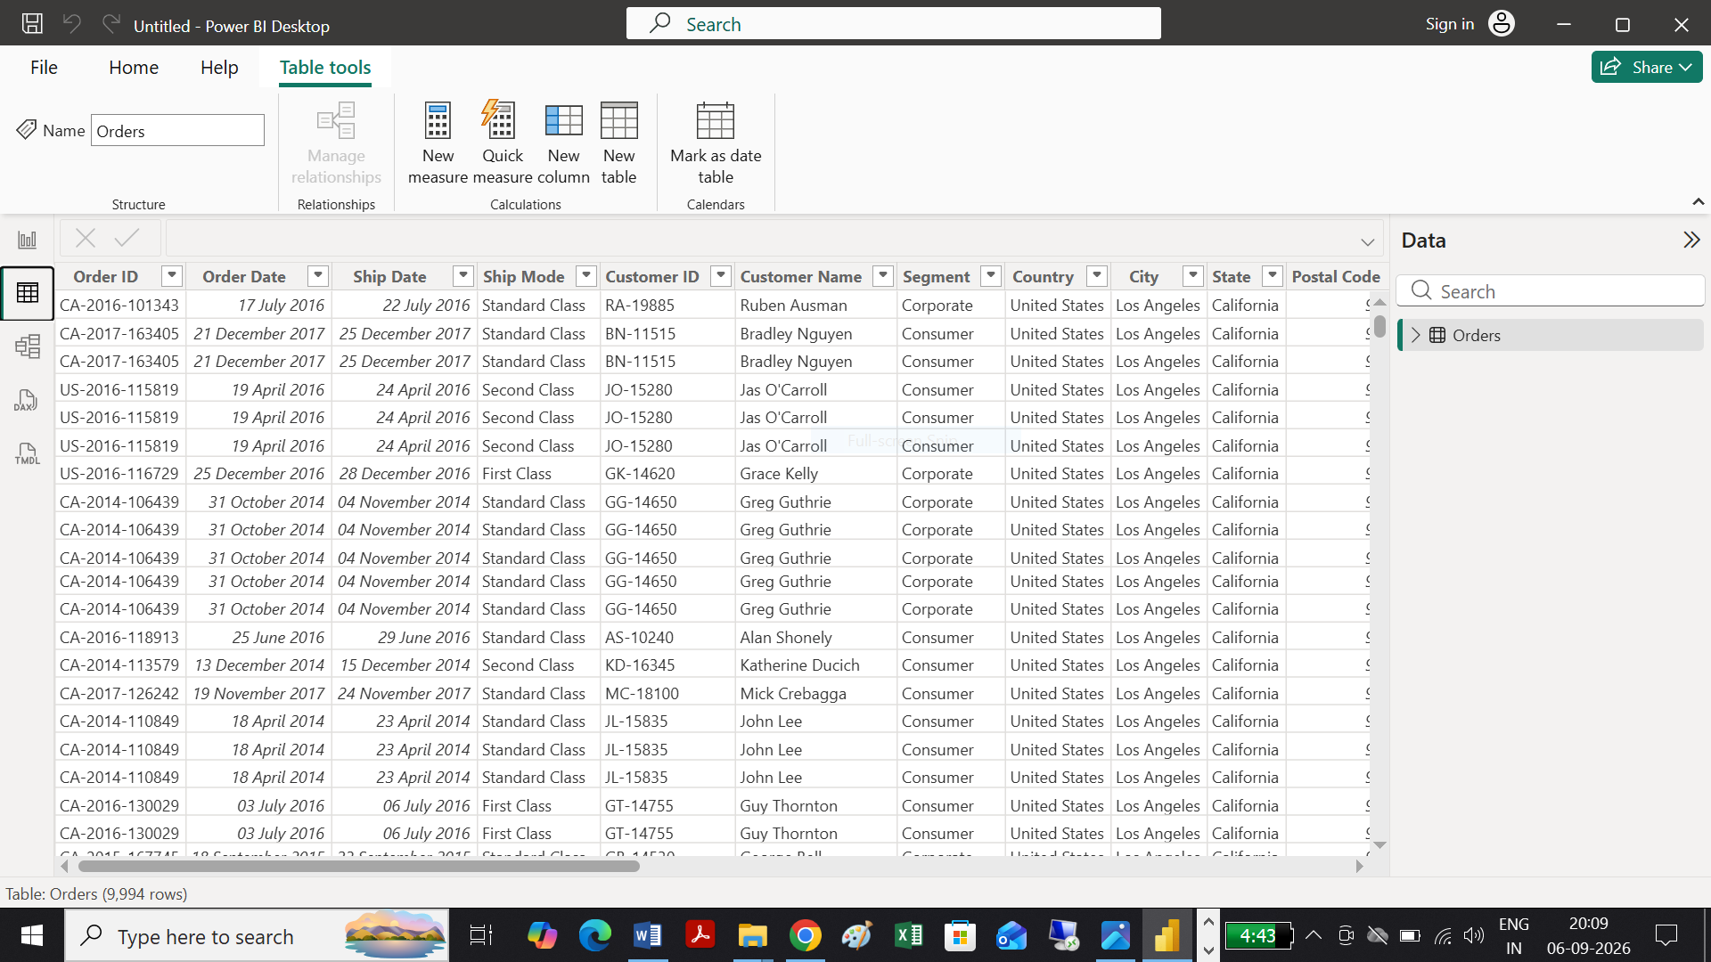

Model View:
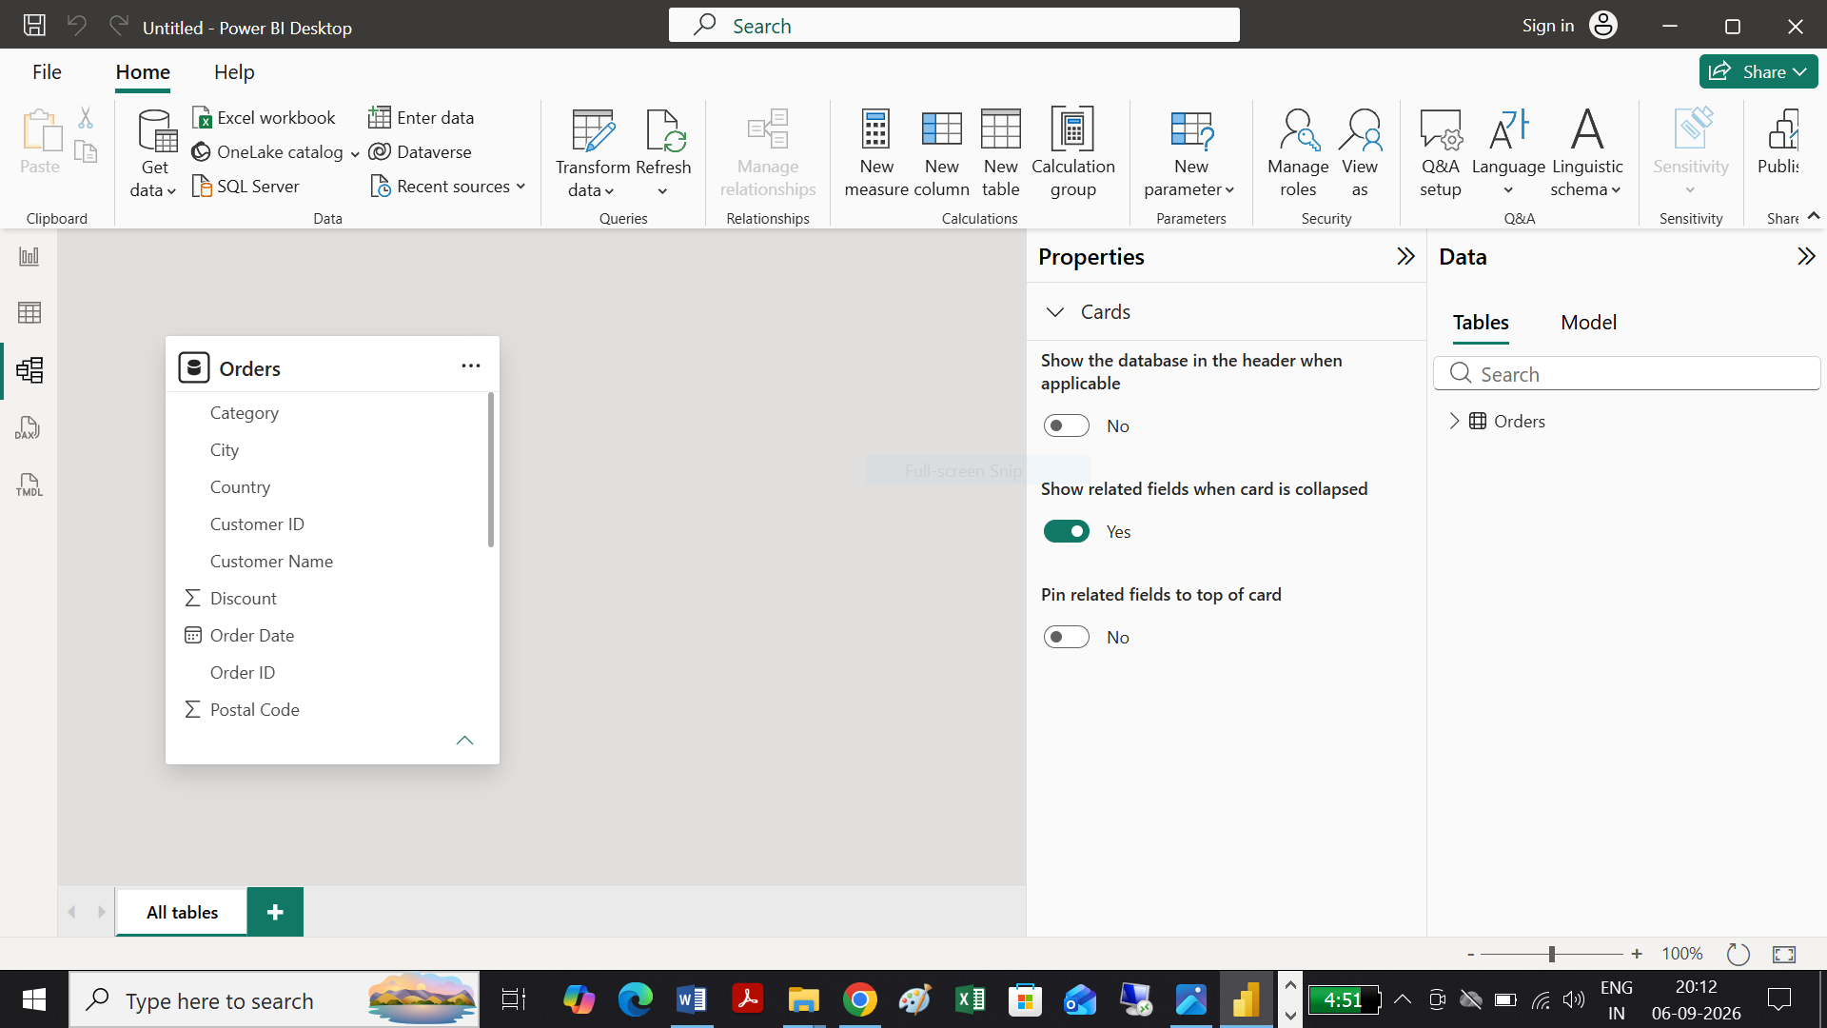

Task 2: BAR CHART & PIE CHART
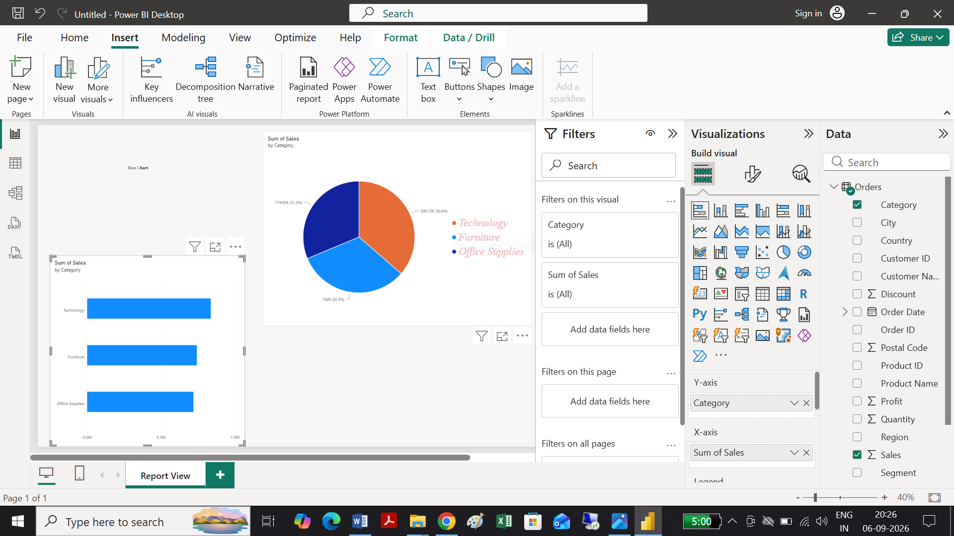
Task 3: Sales Data for Single Category filter Used
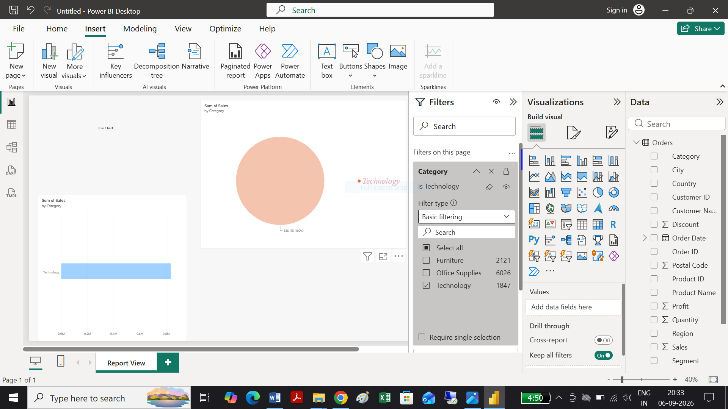

Task 4:
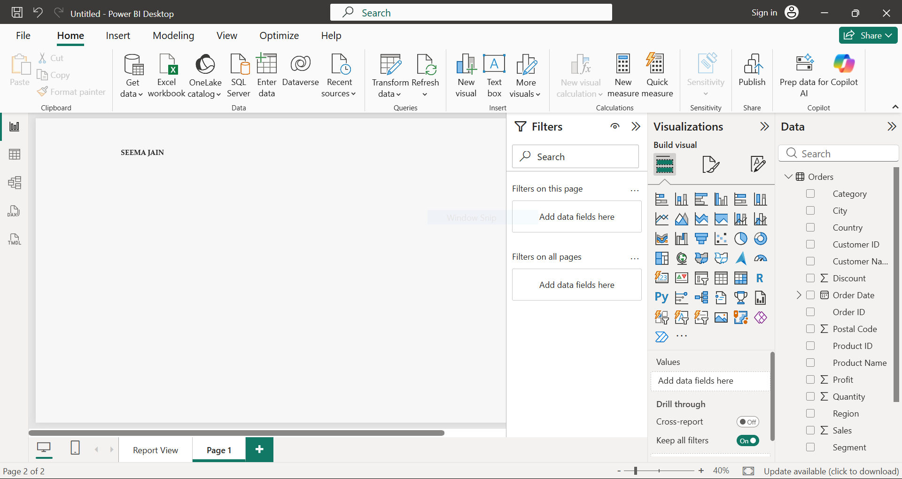

Task 5:
Relationship seen in model view between Shipments & Products and PID is renamed to Product ID as given below:

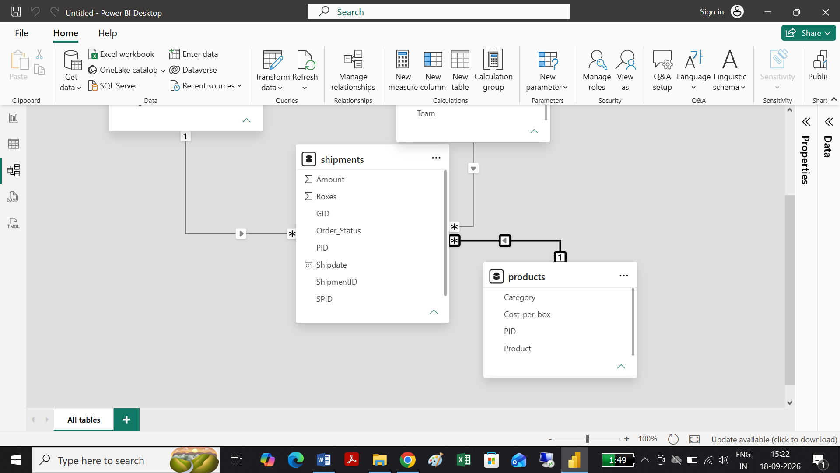
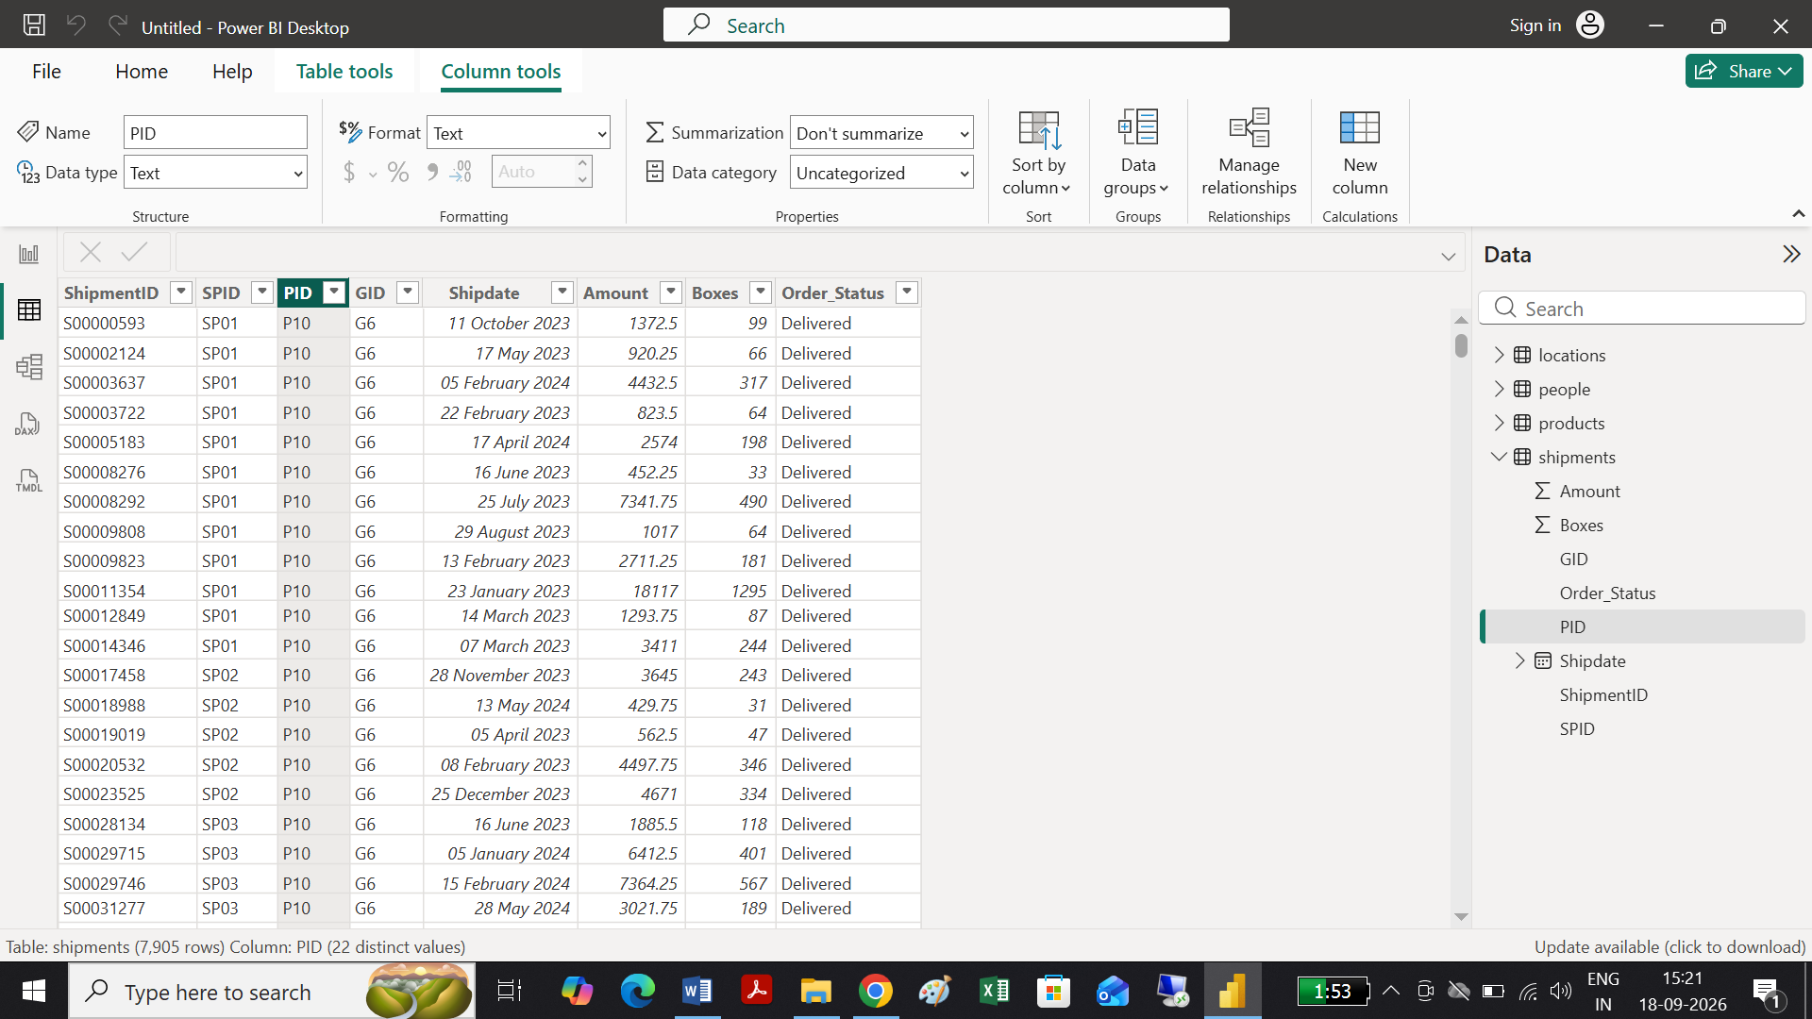
PID Renamed to Product Id
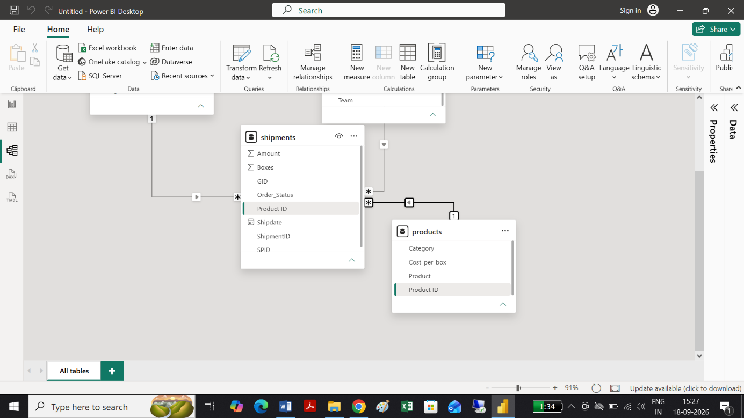

# Session 3:
Tasks 1: Using Above data task 1 query is solved
Data loaded in Power -Bi as such seen in Table view screenshot below
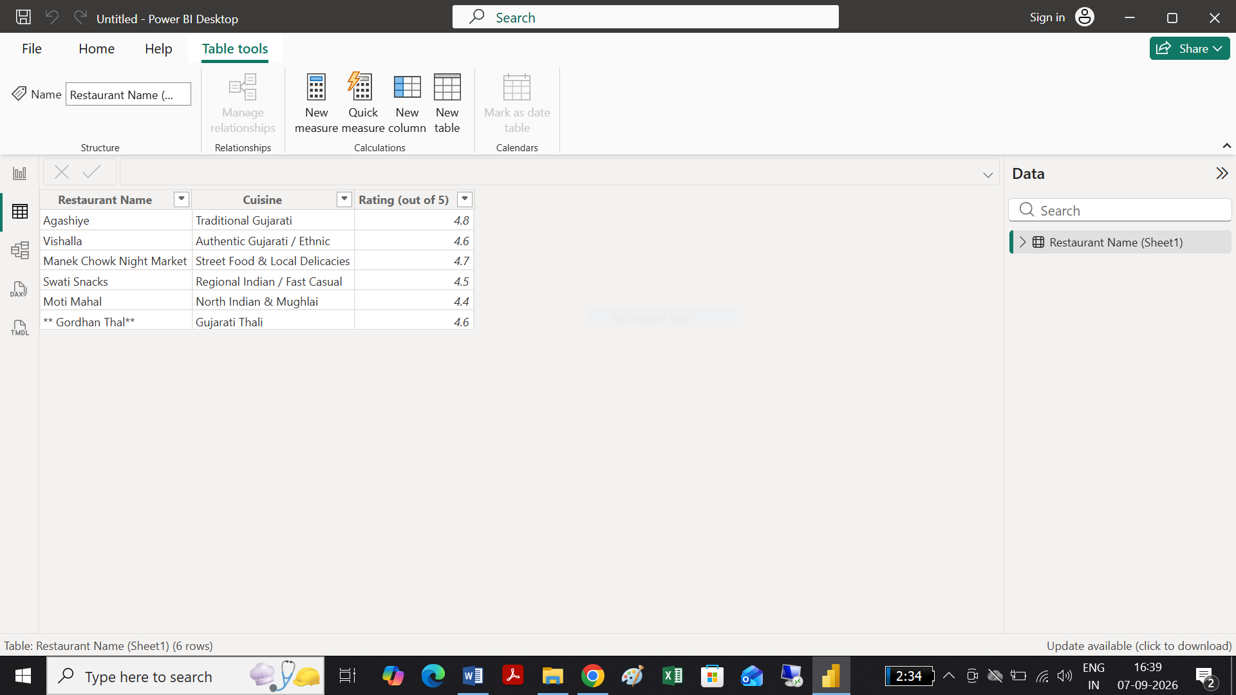
Tasks 2:
Direct Query by Transforming data
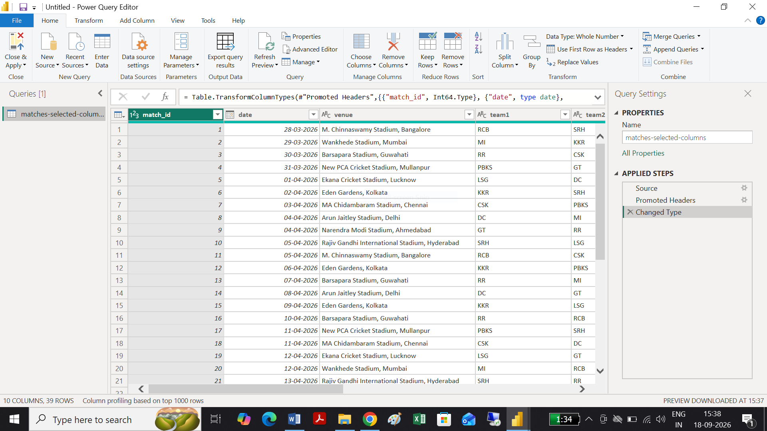
One-line difference: Import copies the data into Power BI for faster analysis, while DirectQuery leaves the data in the source and queries it whenever visuals need data.
So, for the provided CSV, use Import mode; you cannot directly select DirectQuery for this file.
Tasks 3: Pending
Task 4: Connect Power bi to SQL : Pending

Task 5: Using below data task 5 query is solved

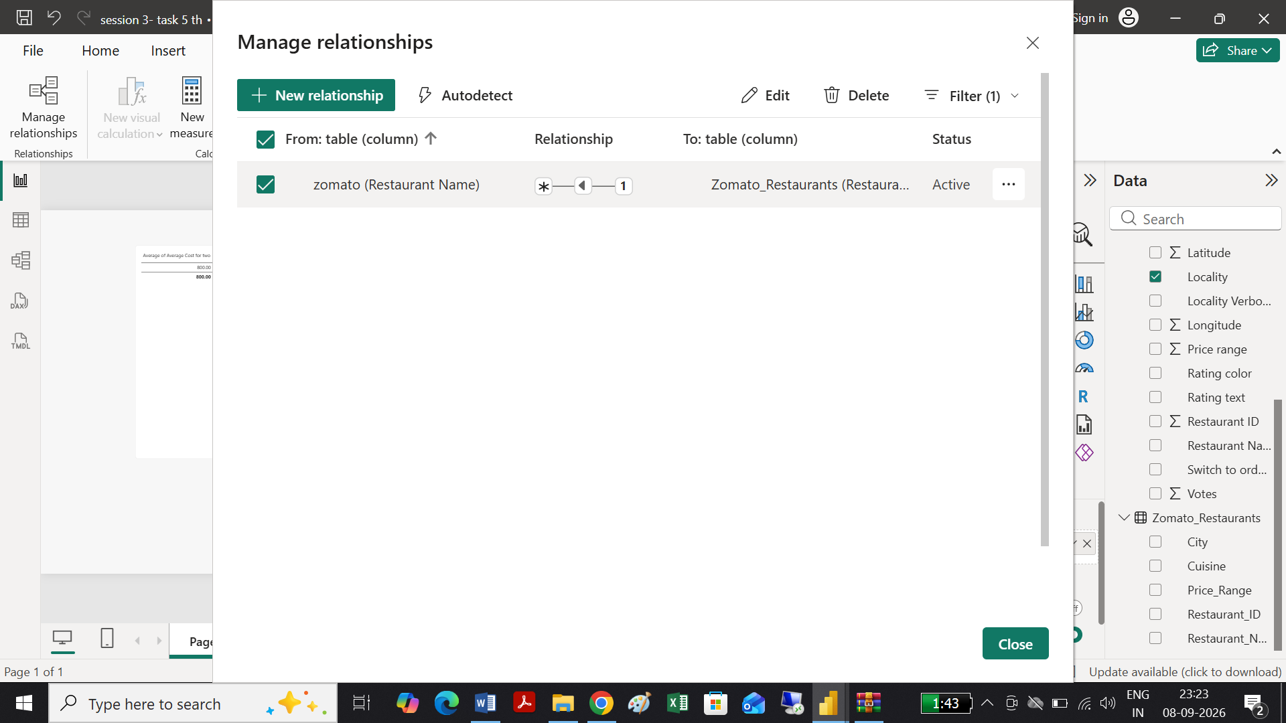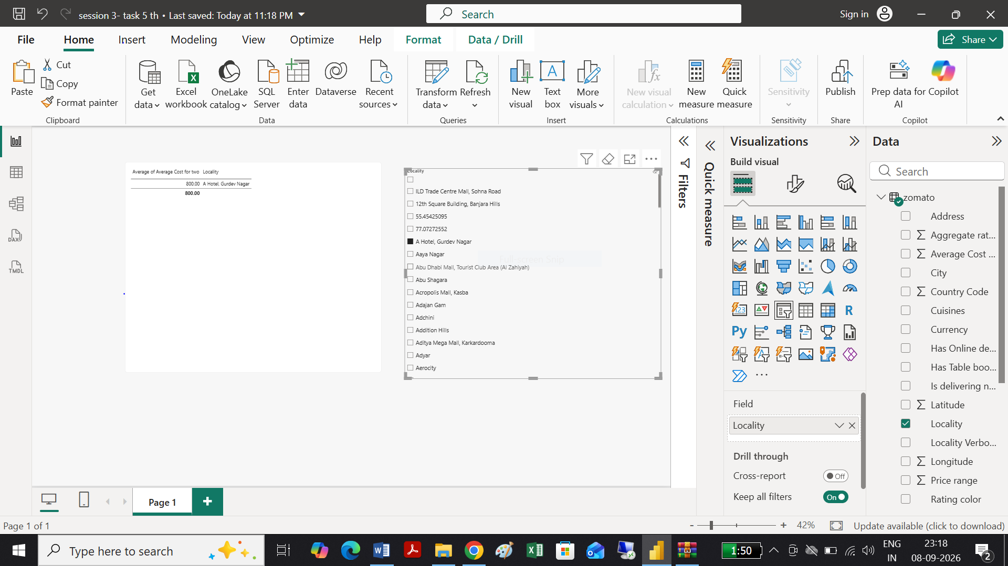

# Session 4:
Tasks 1:
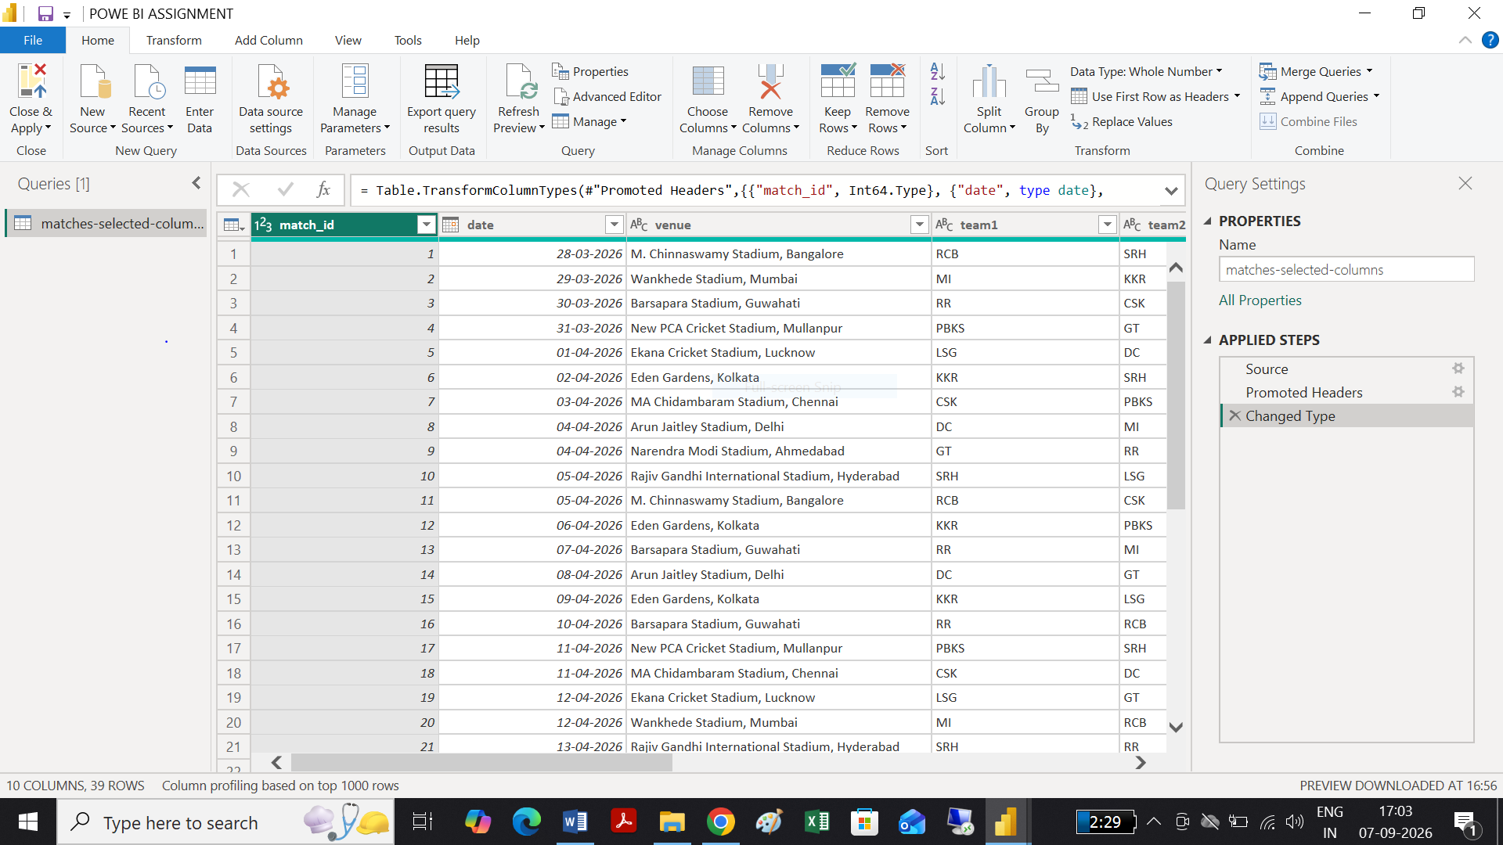

Tasks 2:
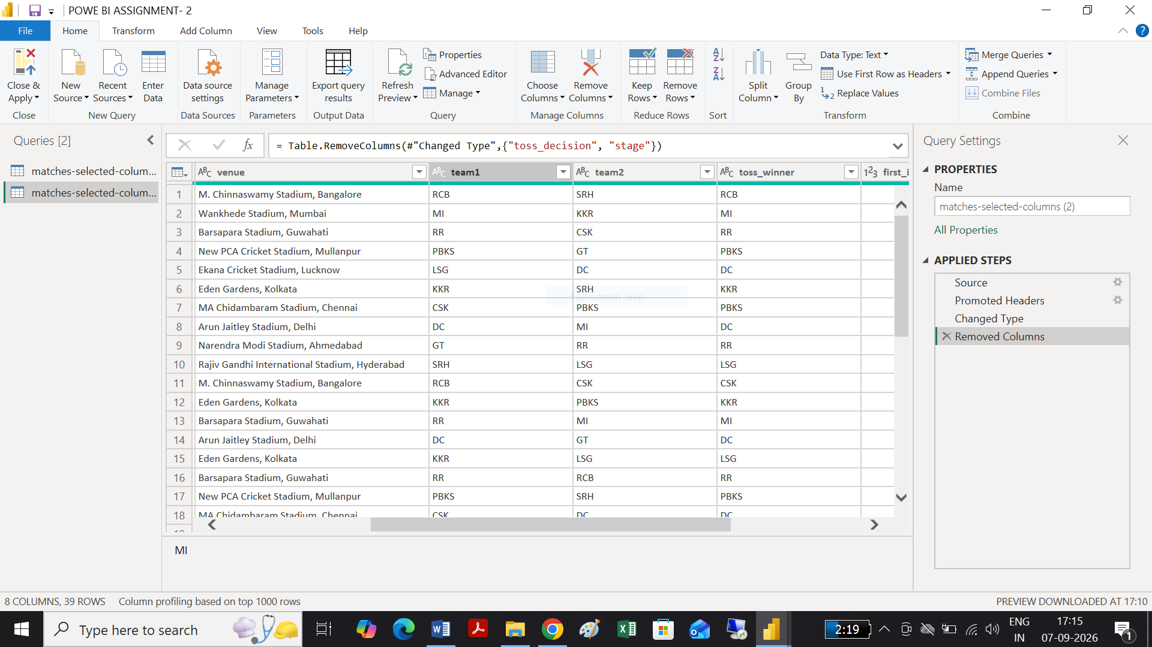
Task 3:
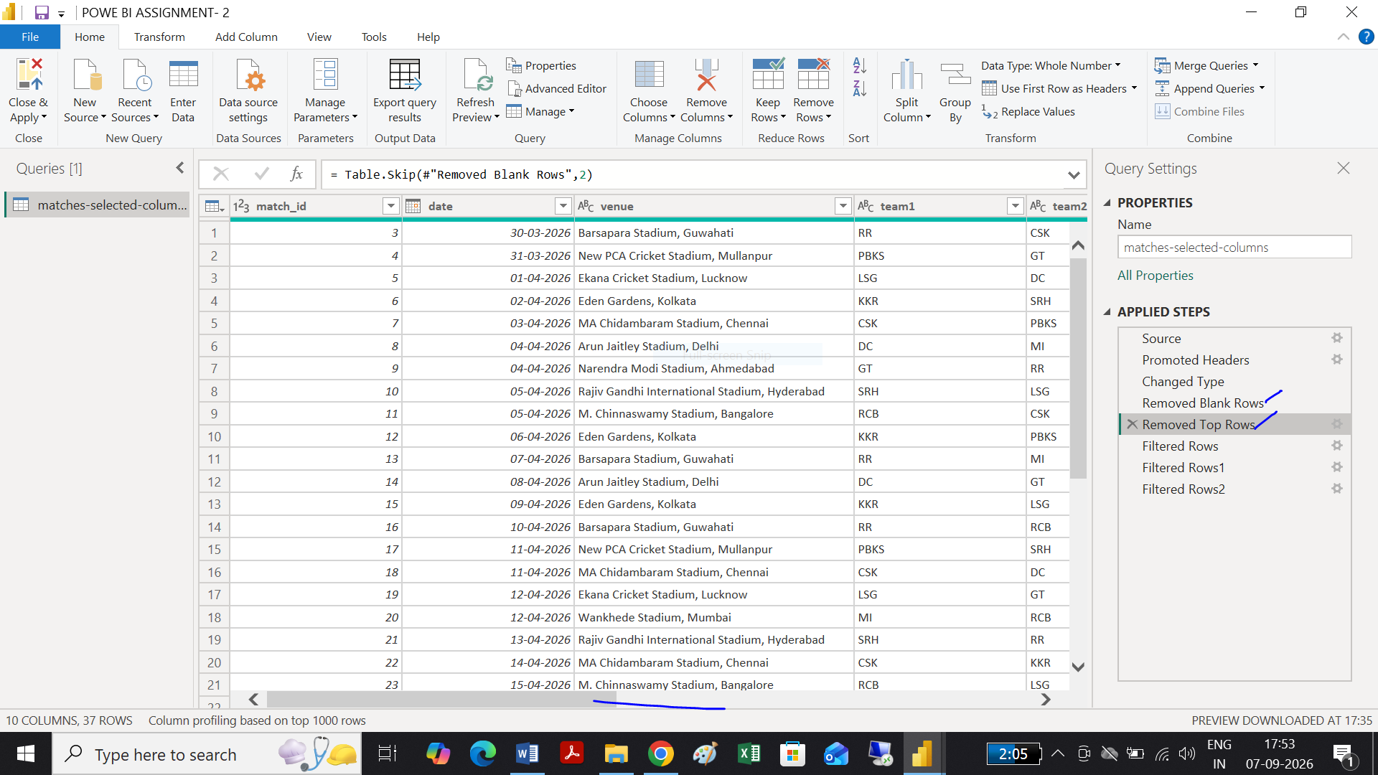

Task 4:
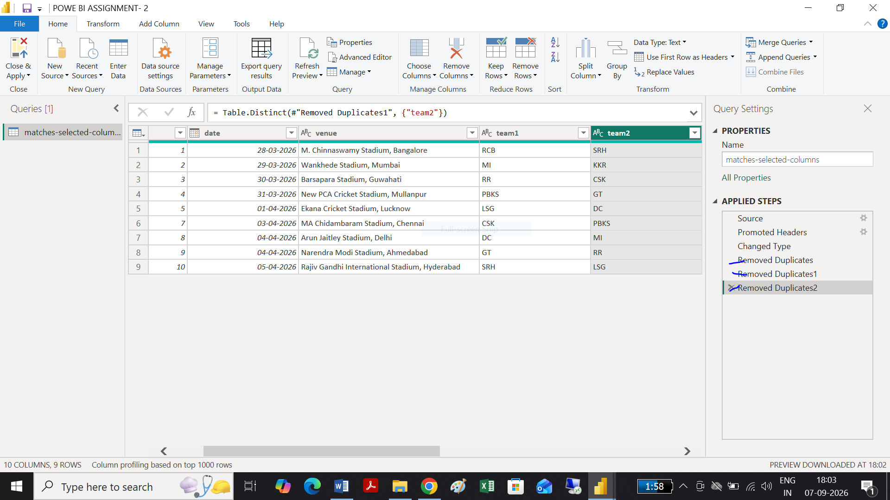

Task 5:
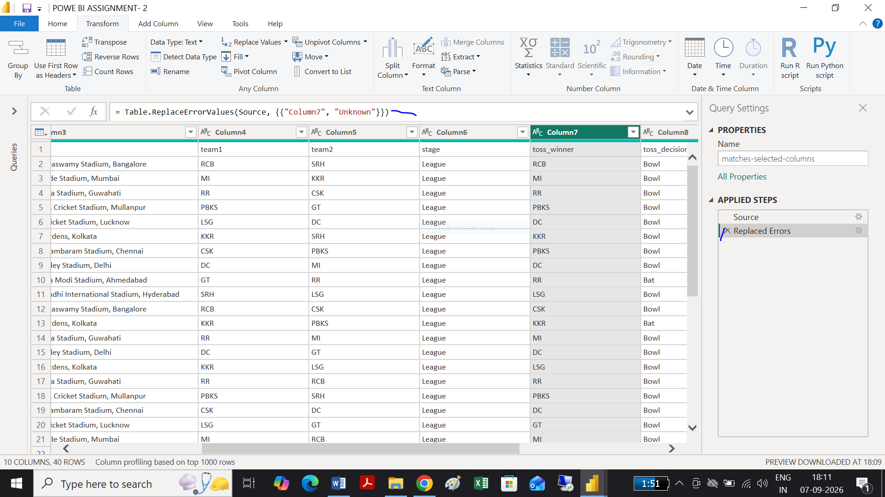

# Session 5:
Tasks 1:
Using Above data task 1 query is solved
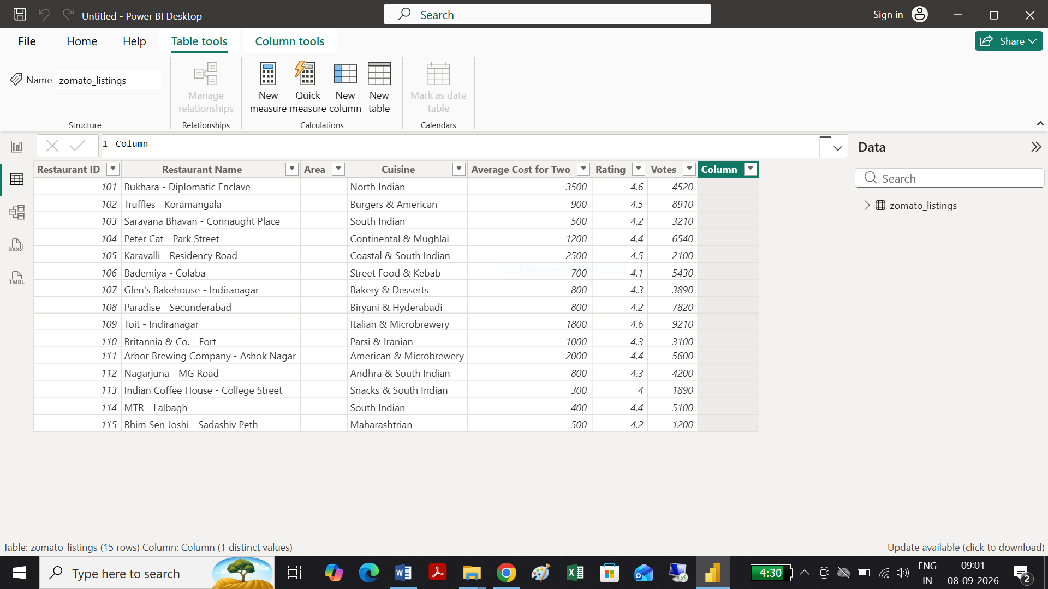
Task 2:

Using Above data task 1 query is solved
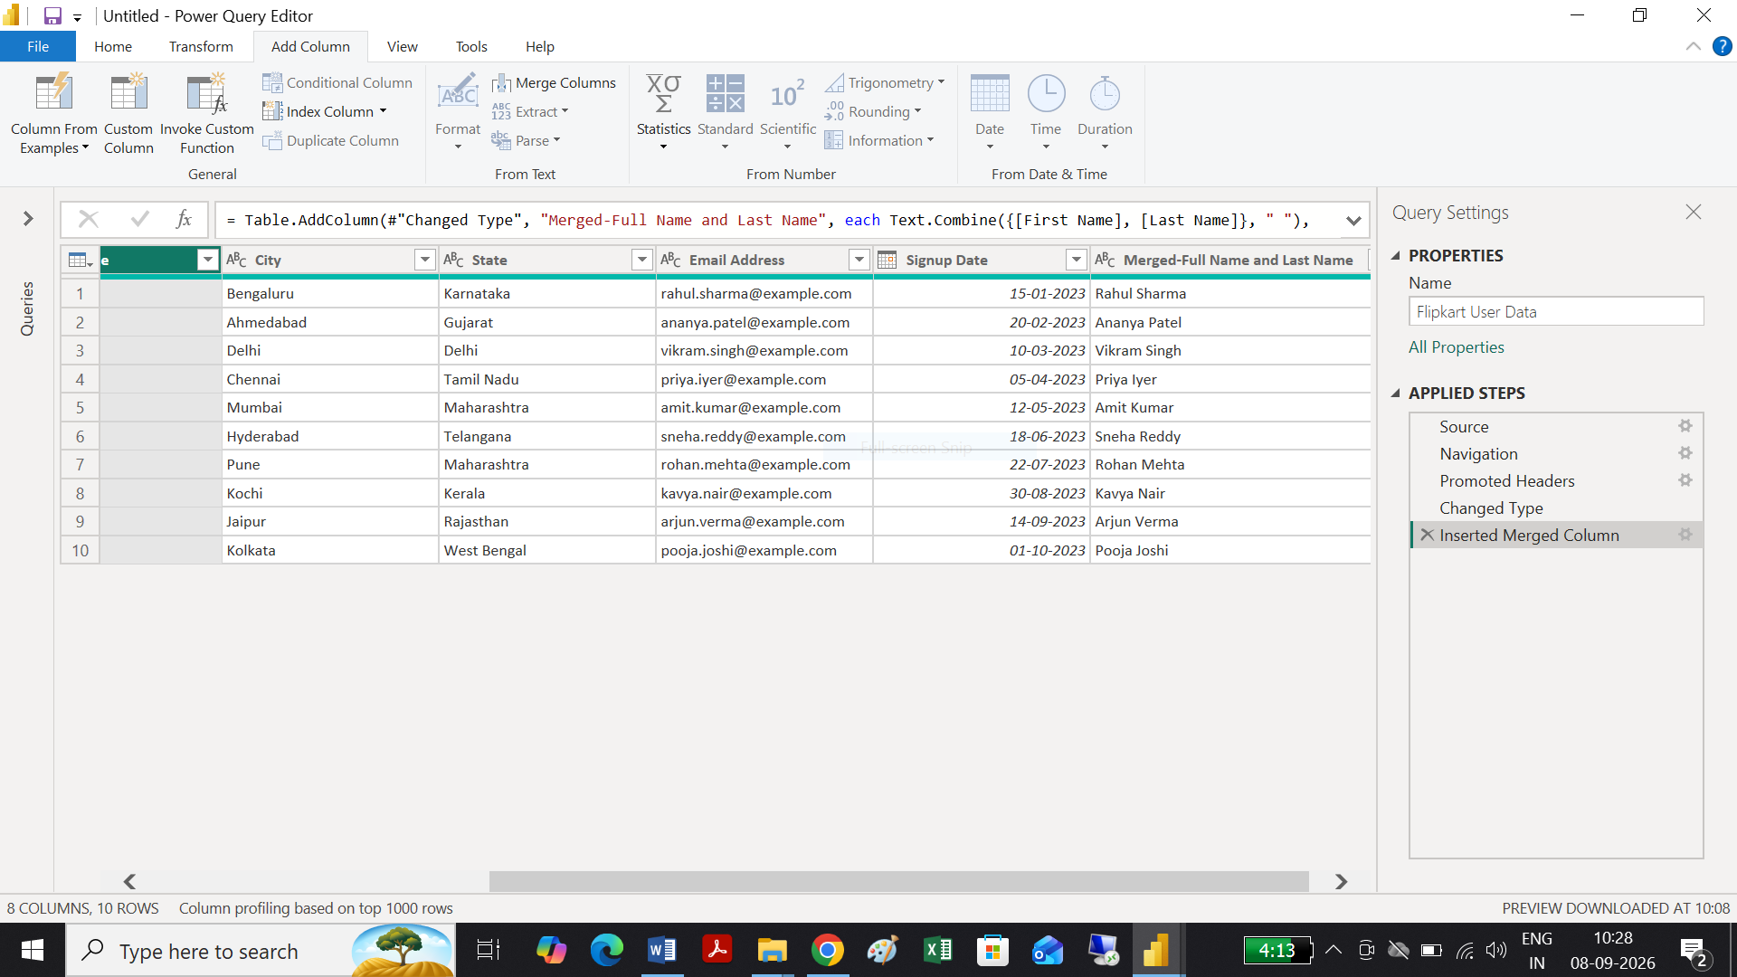

Tasks 3:
Using Above data task 1 query is solved
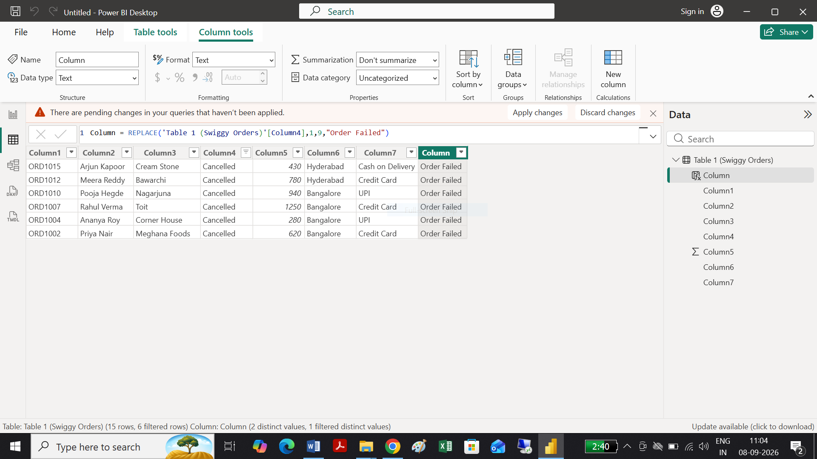

Task 4:
Using Above data task 1 query is solved

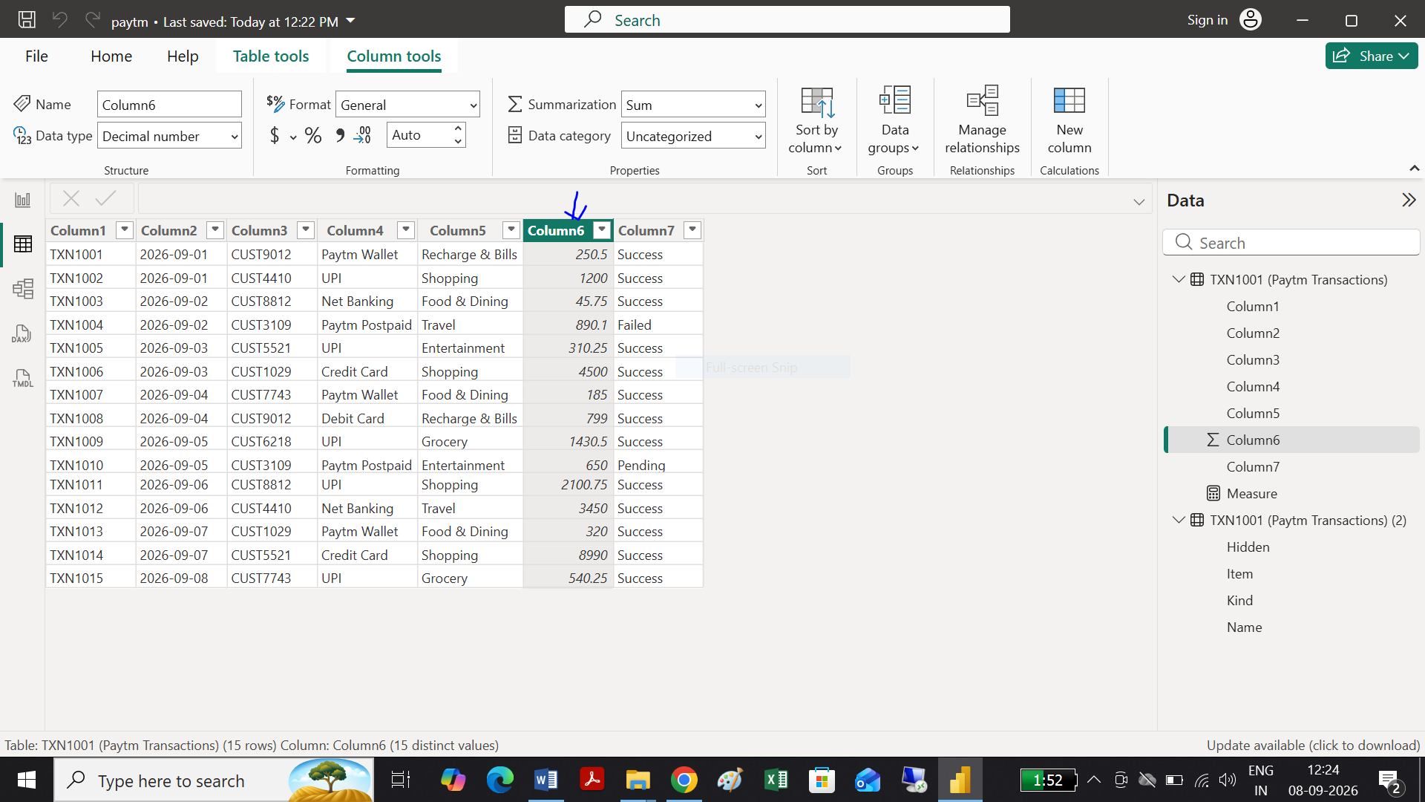

And as seen below sum of column by graph and measure is same as per the query request the numeric value required

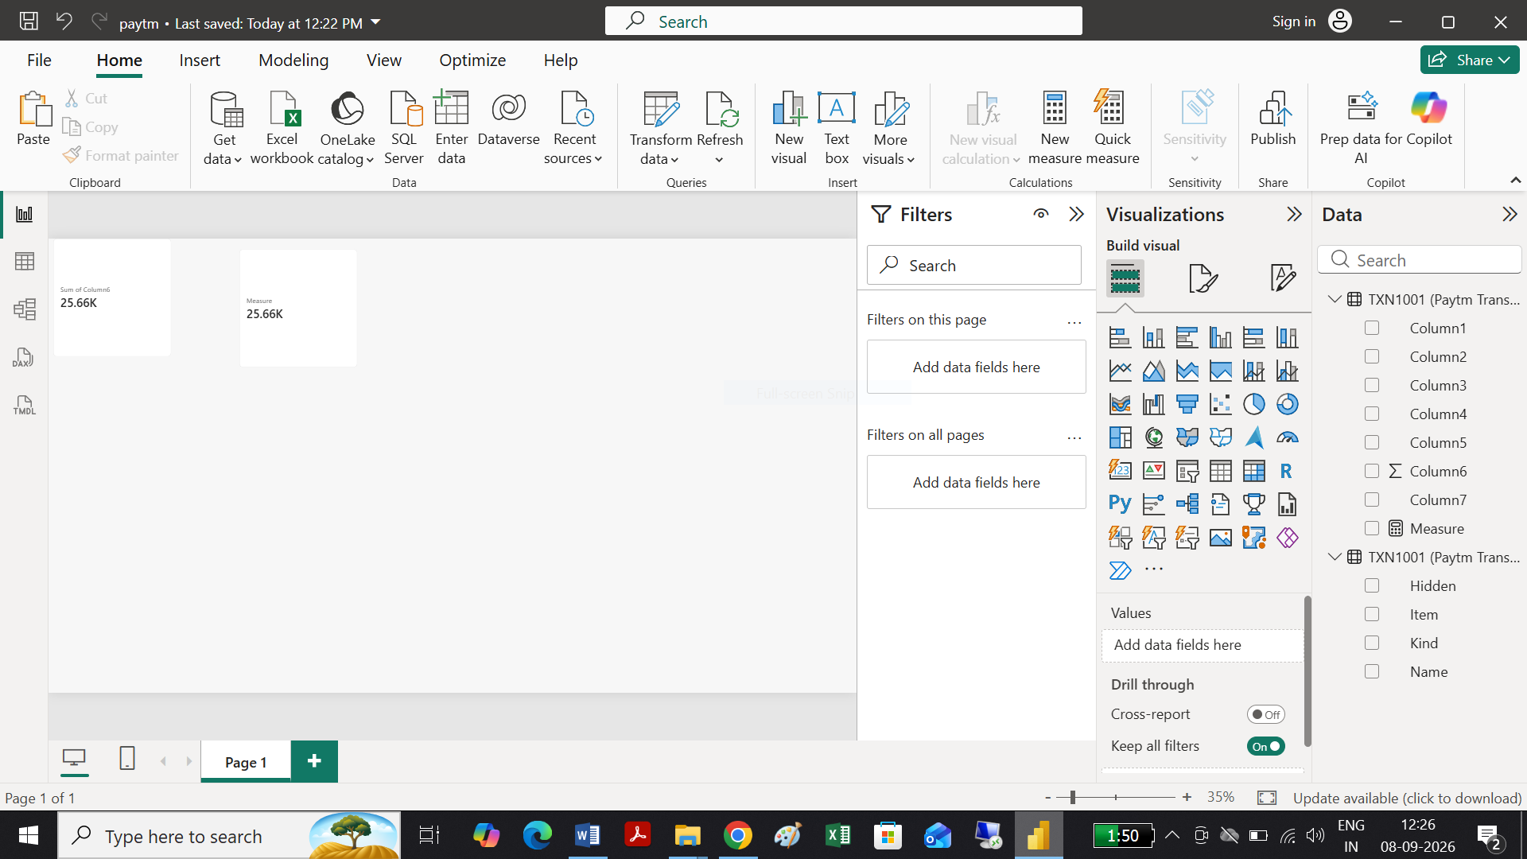

Task 5:

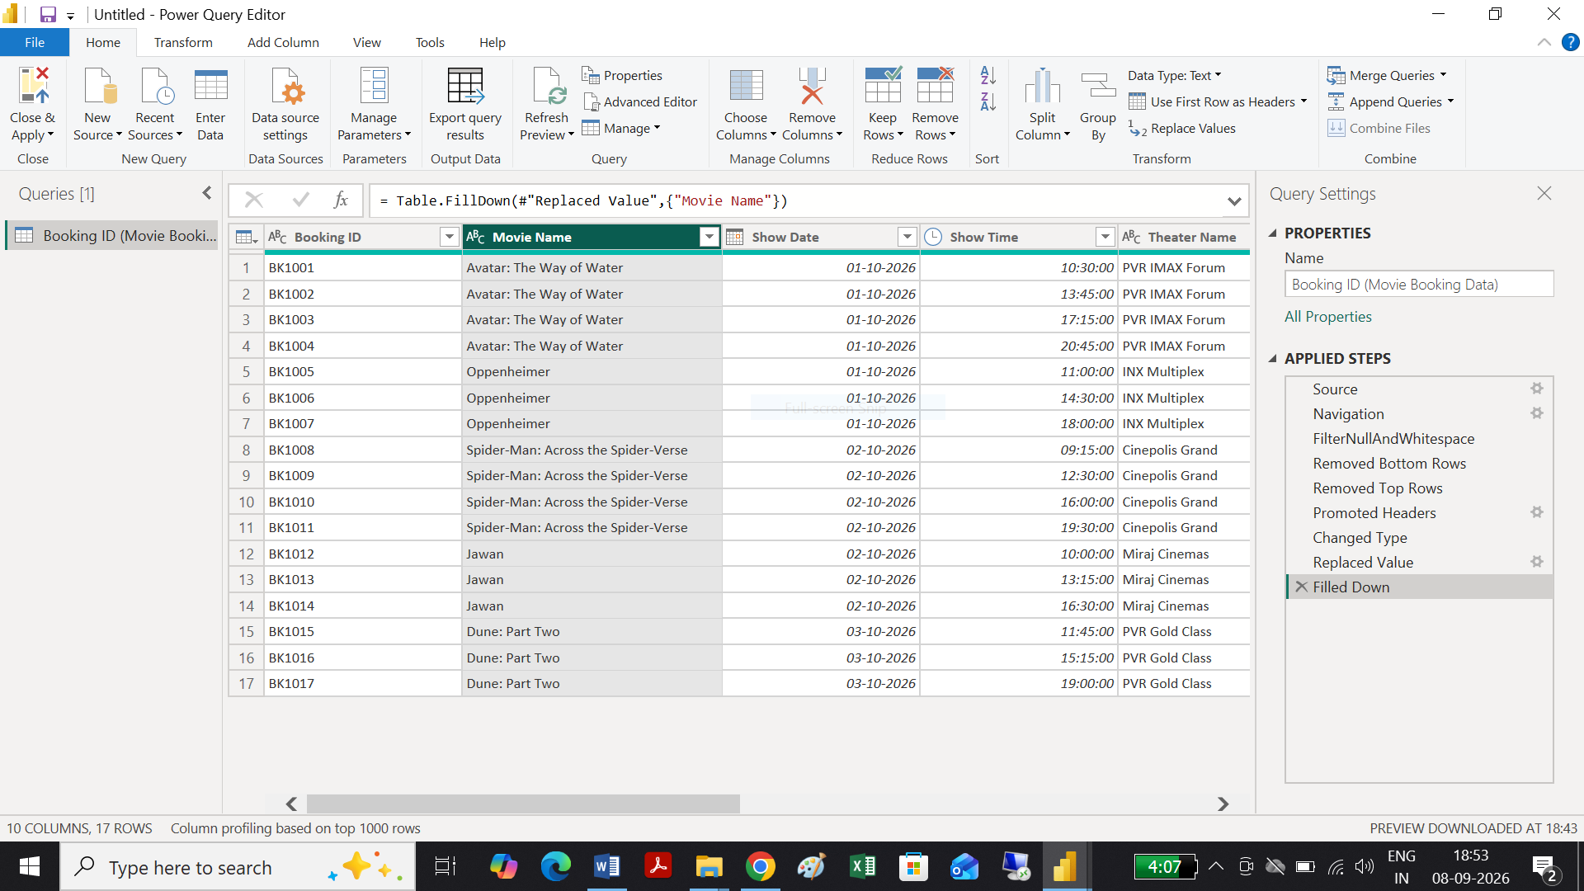
Same as above query solved seen in Table view below as seen:
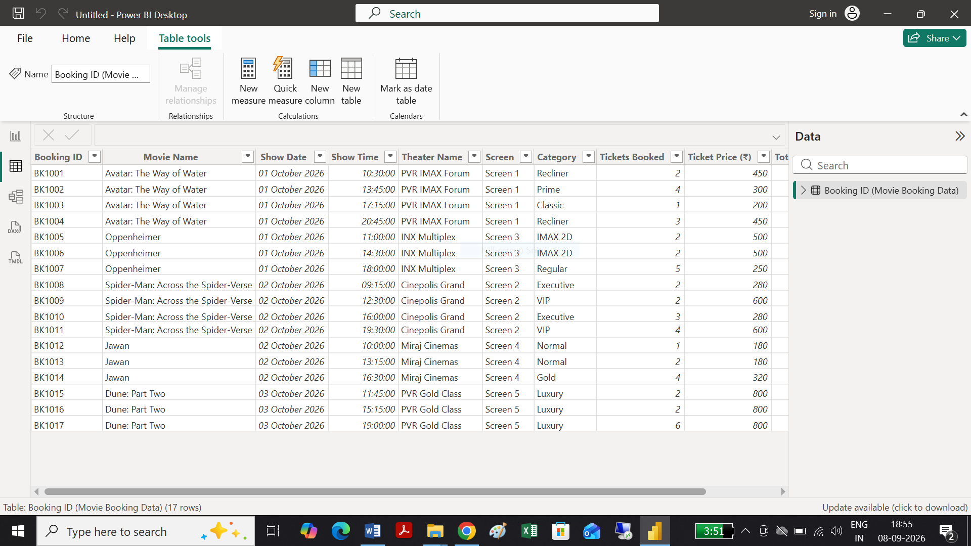

Session 6:
Task 1:
Using below data task 1 query is solved

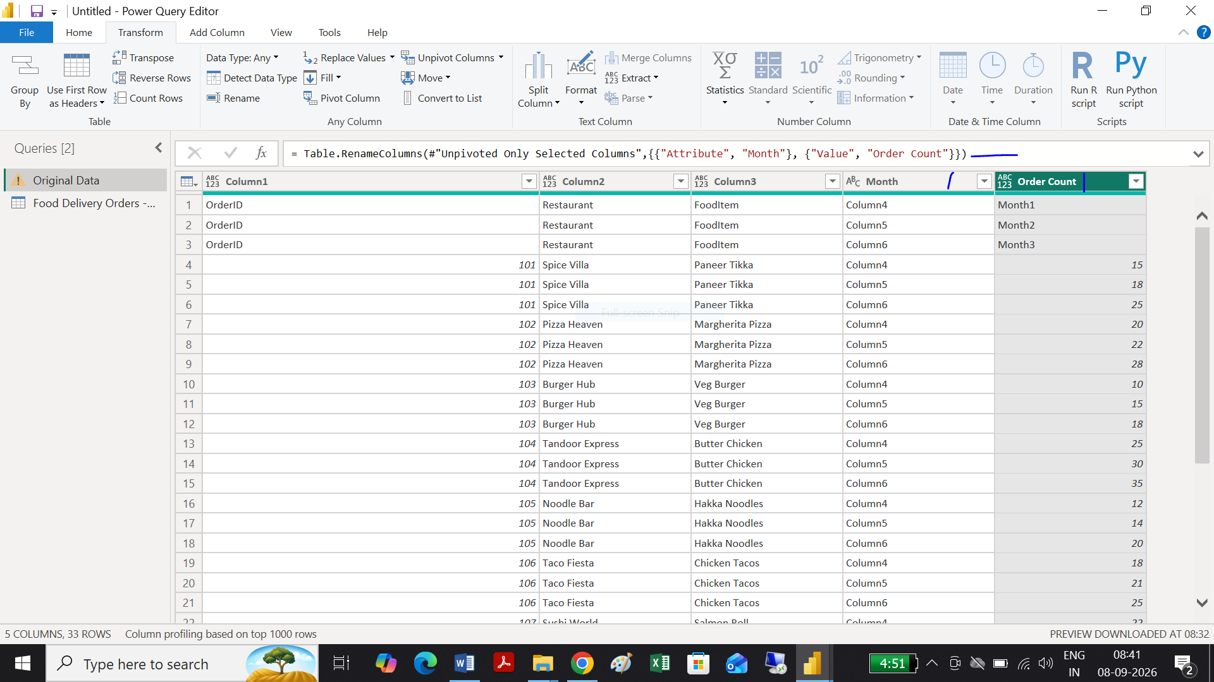

Task 2:

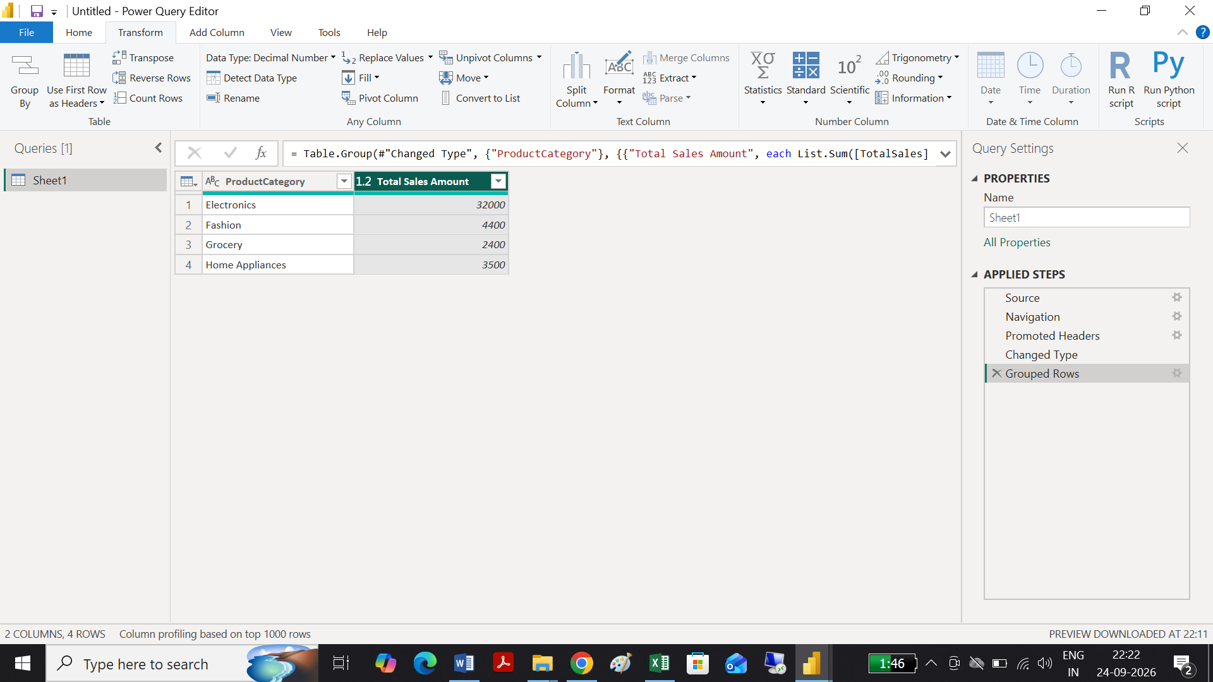

Task 3:
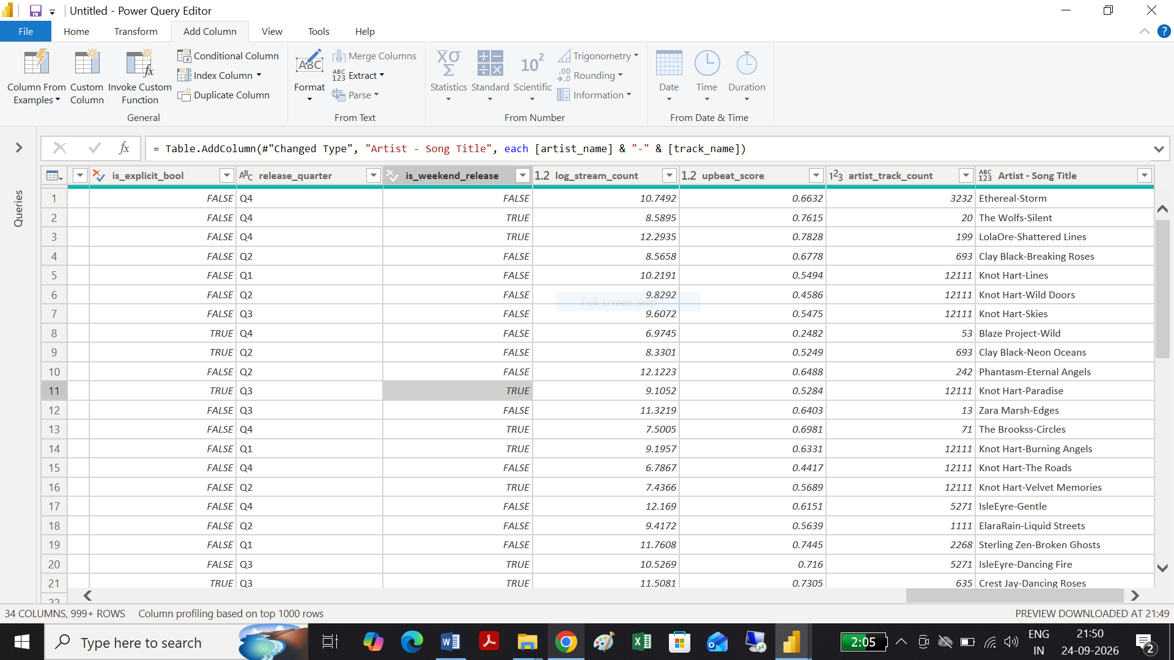

Task 4:
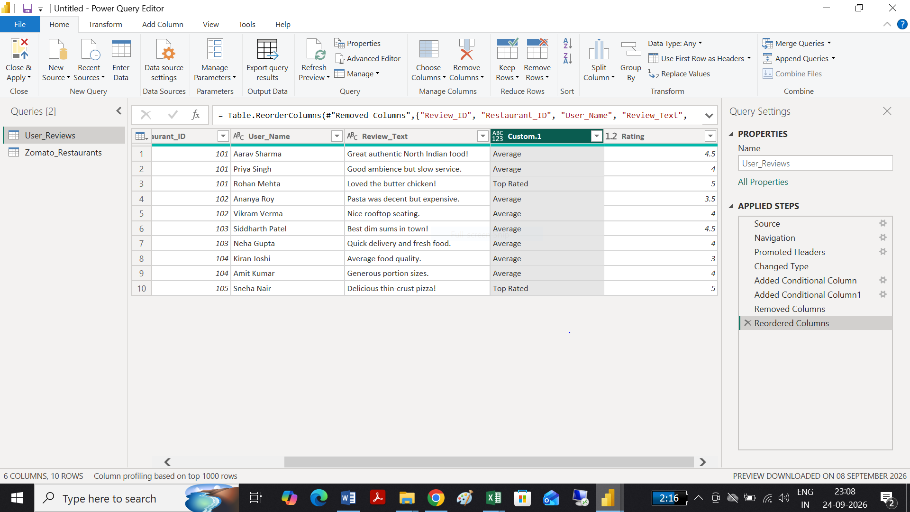

Task 5:

Session 7:
Task 1:
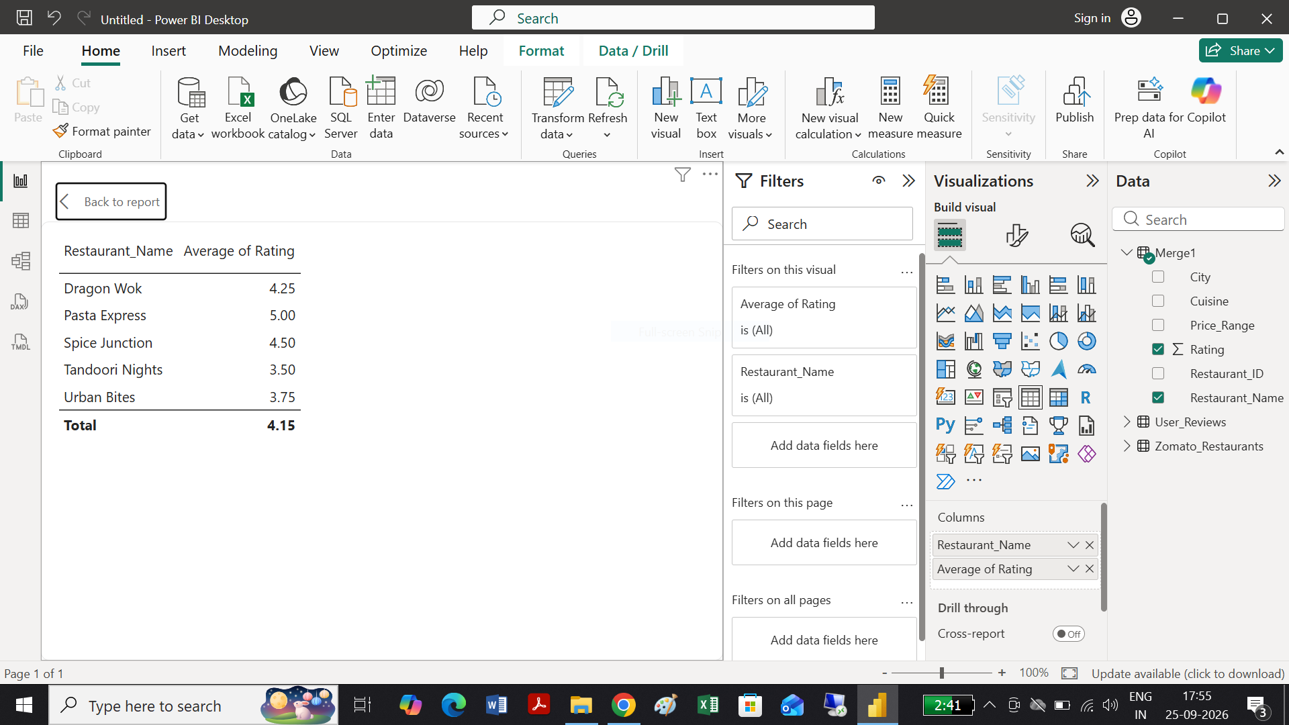

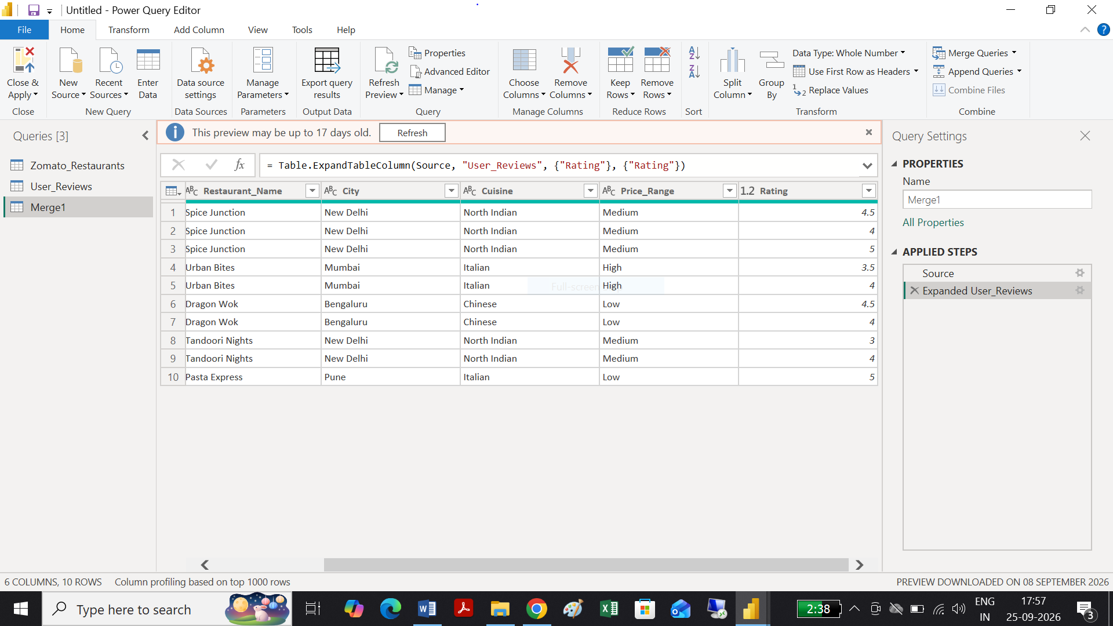

Task 2:

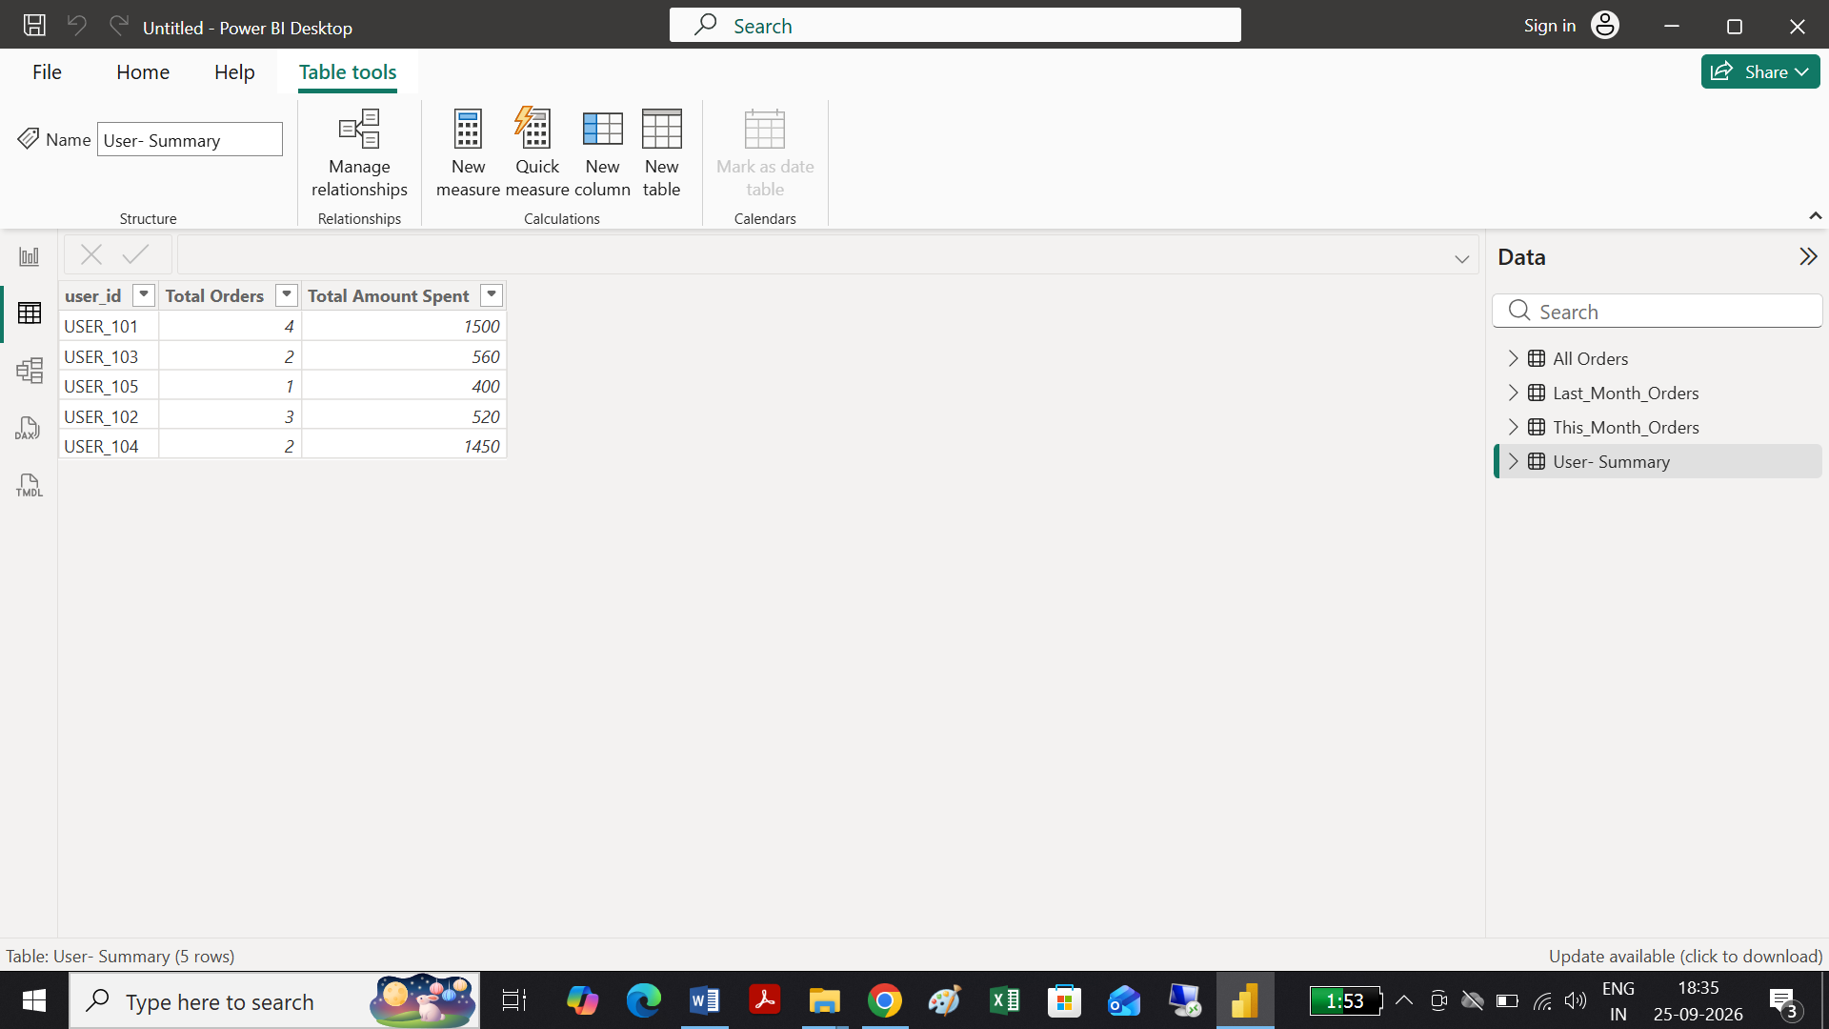
Task 3:

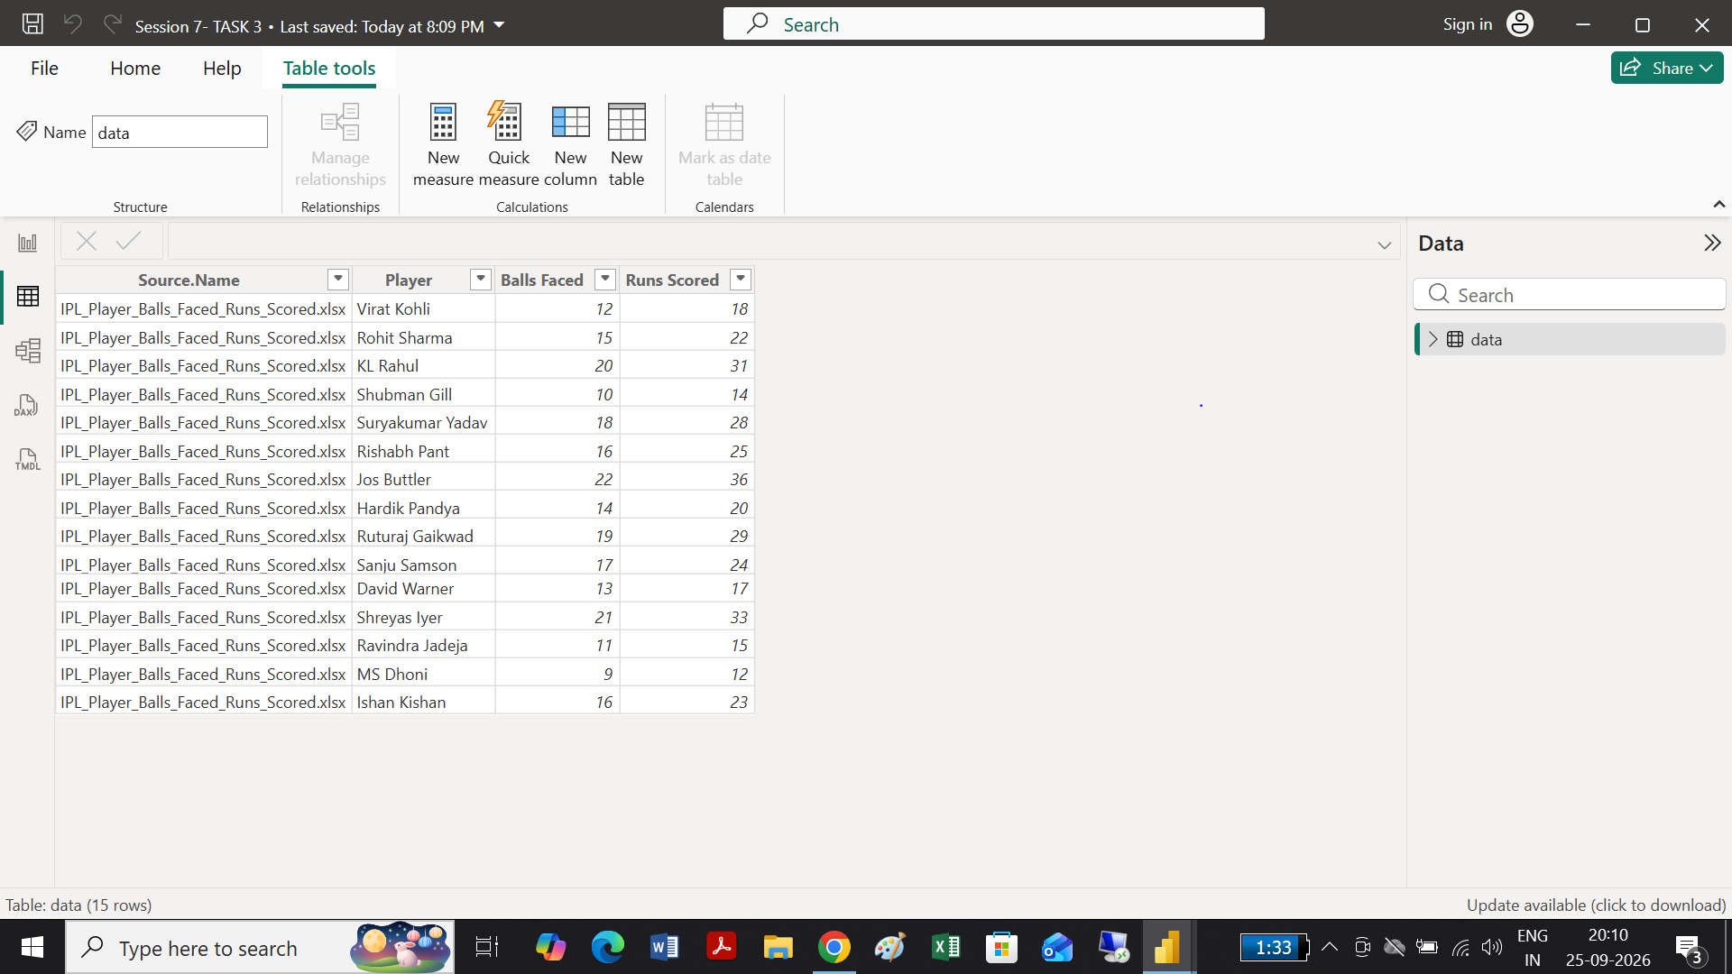
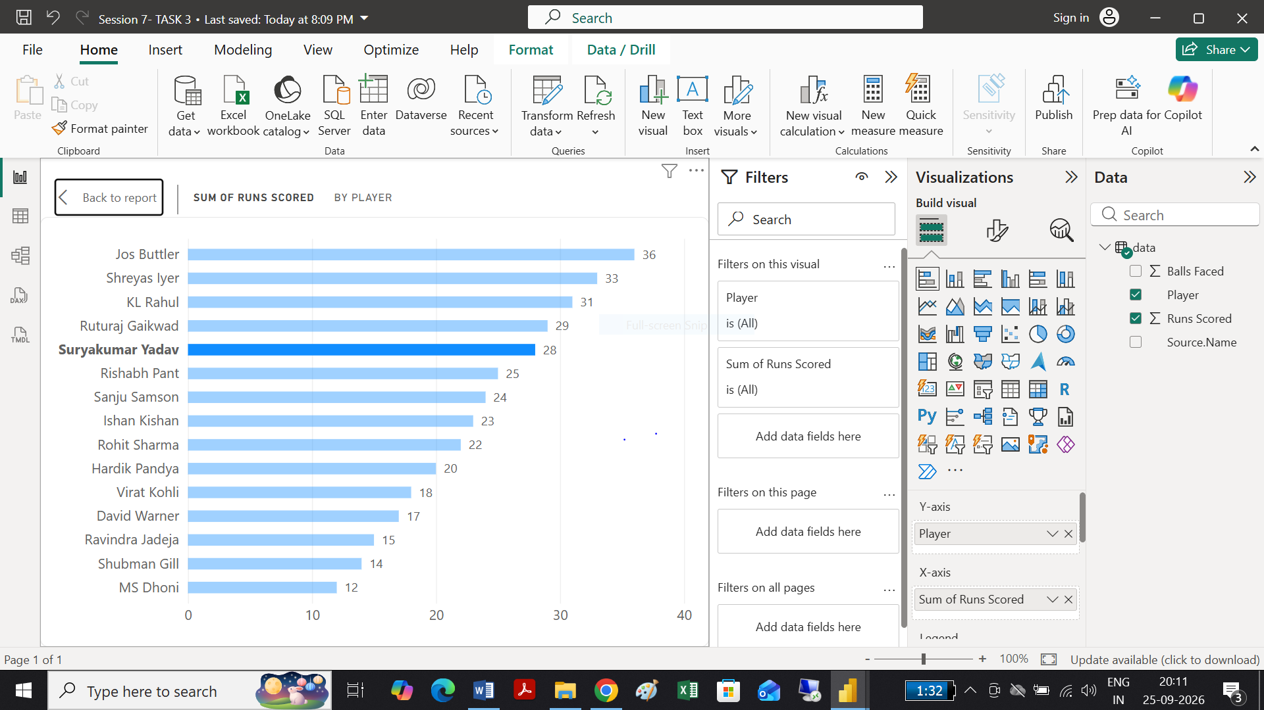

Task 4:
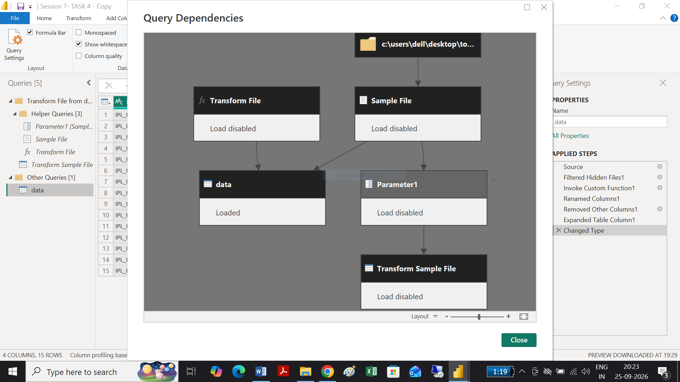

Session 8:
Task 1:
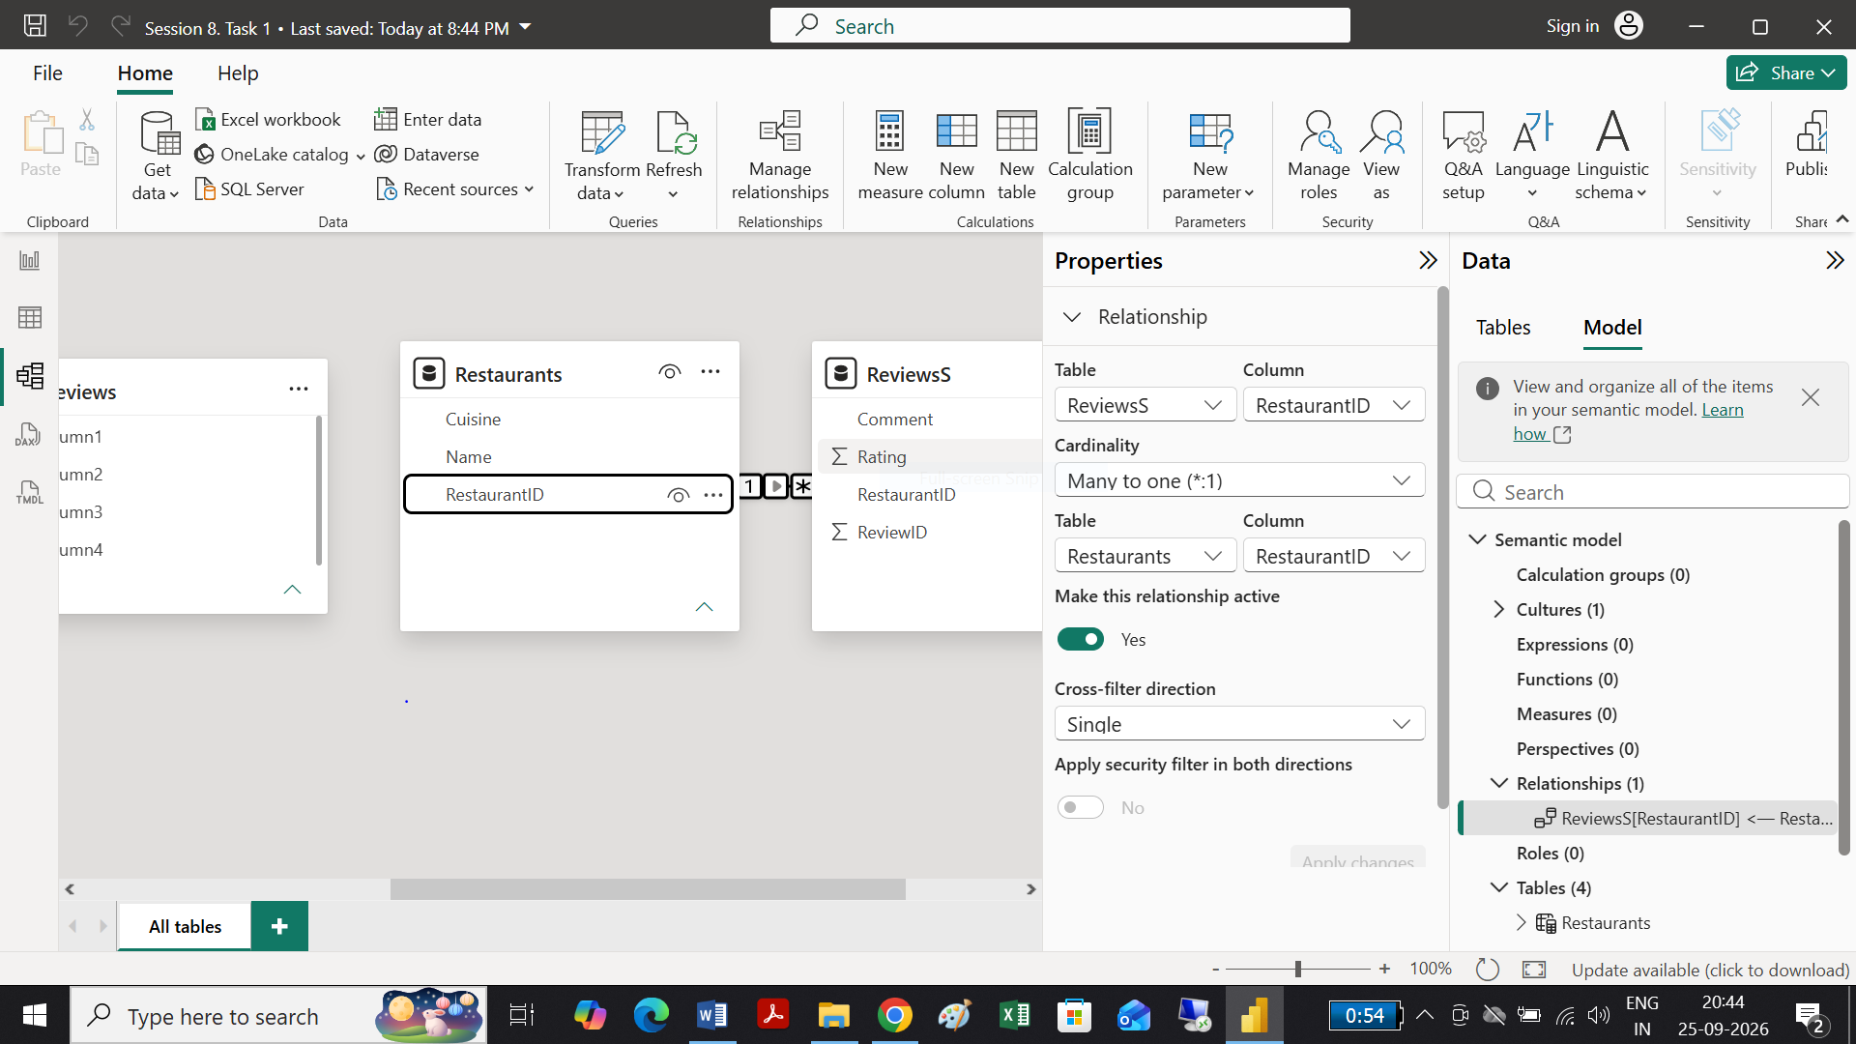

Task 2:
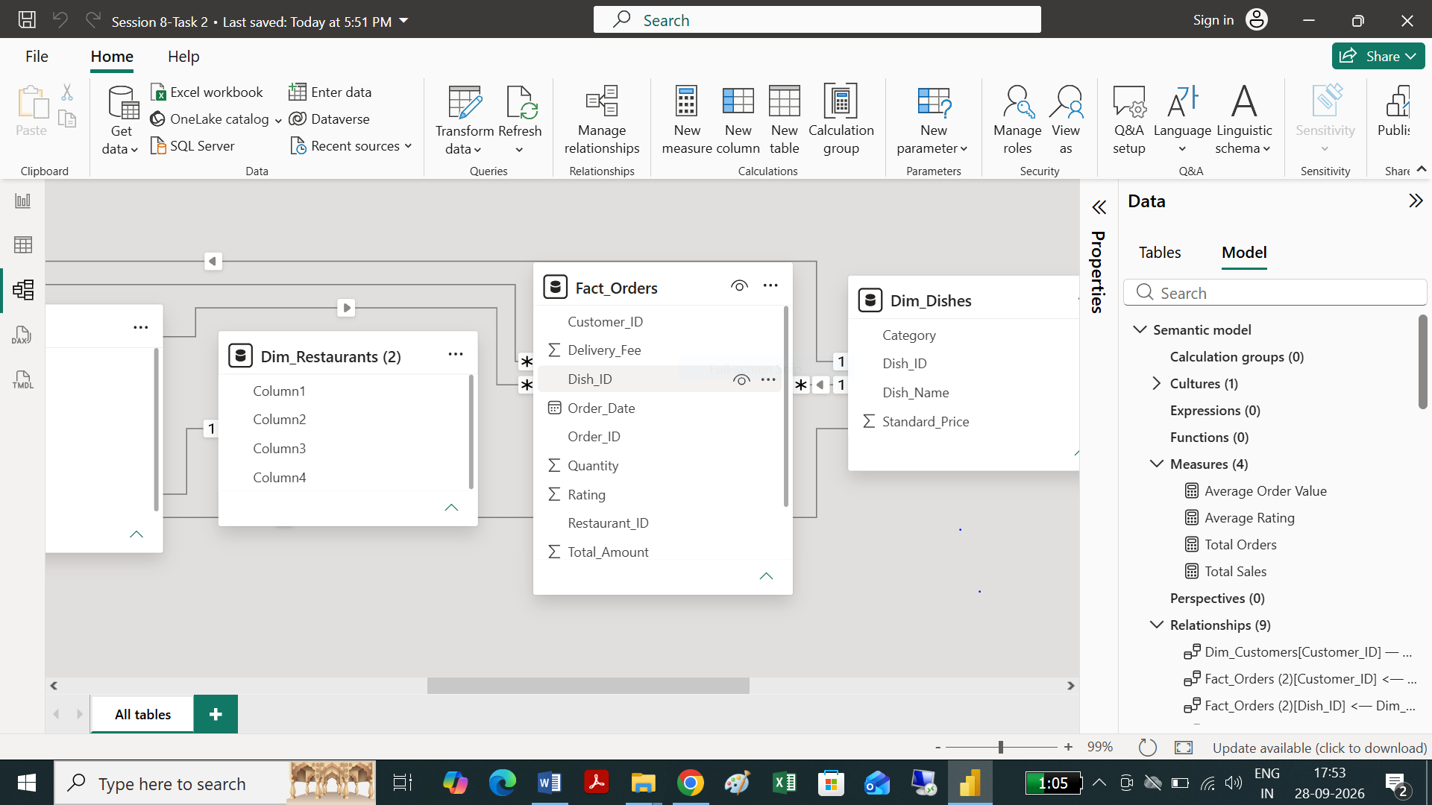

Task 3:

Task 4:

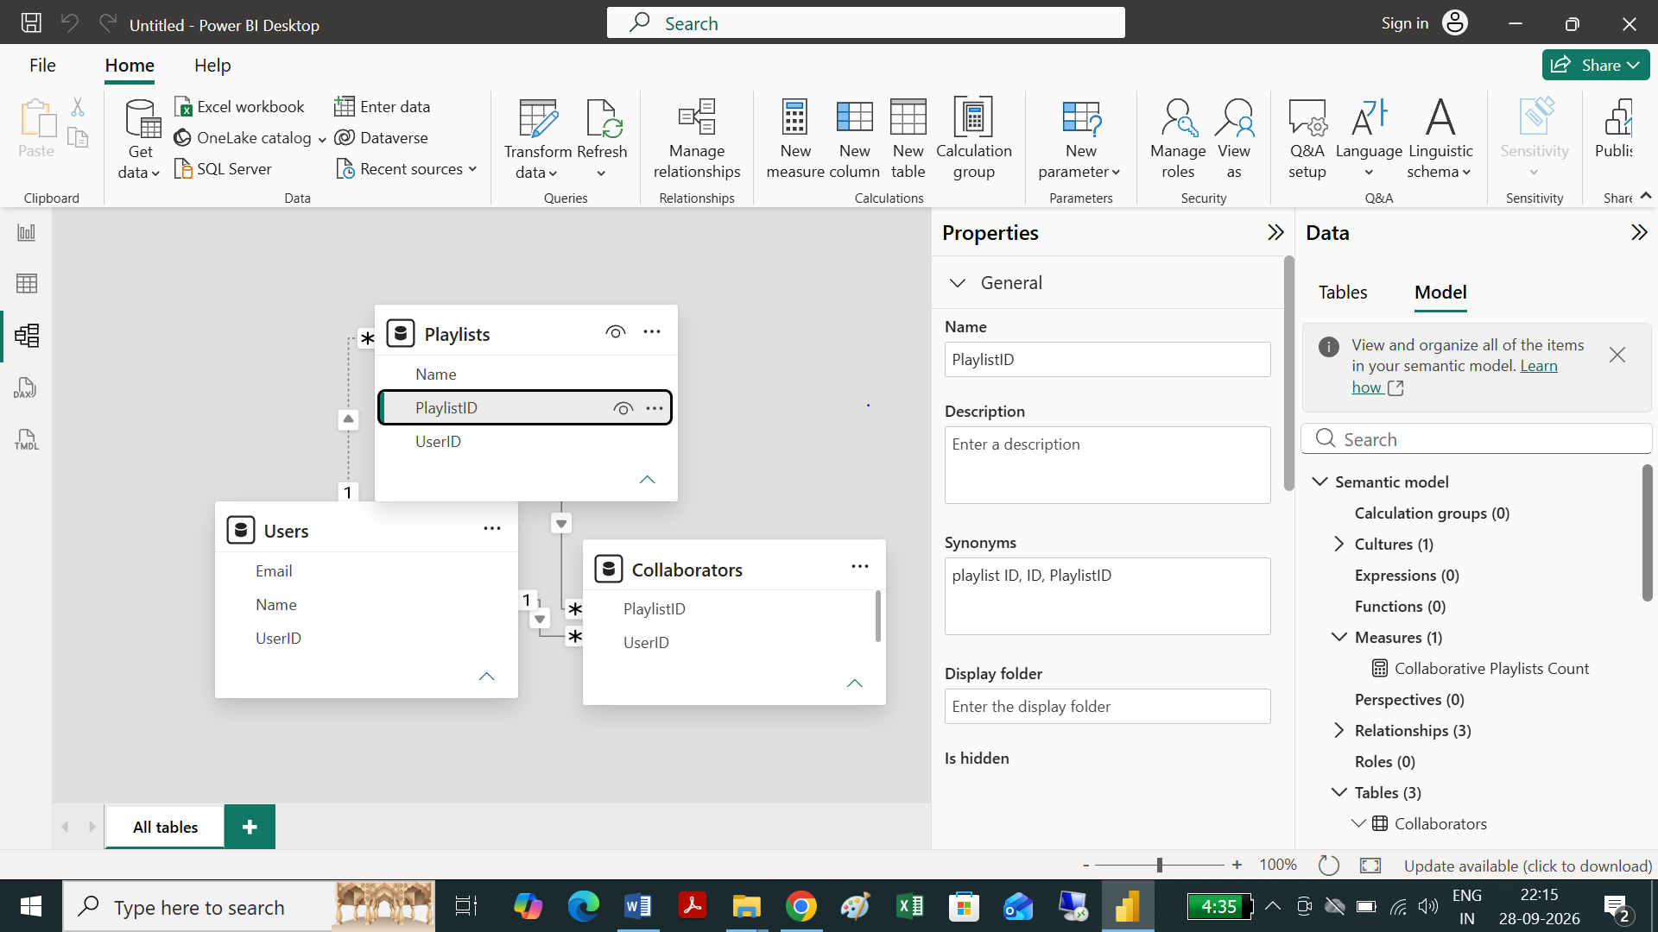
Task 5:

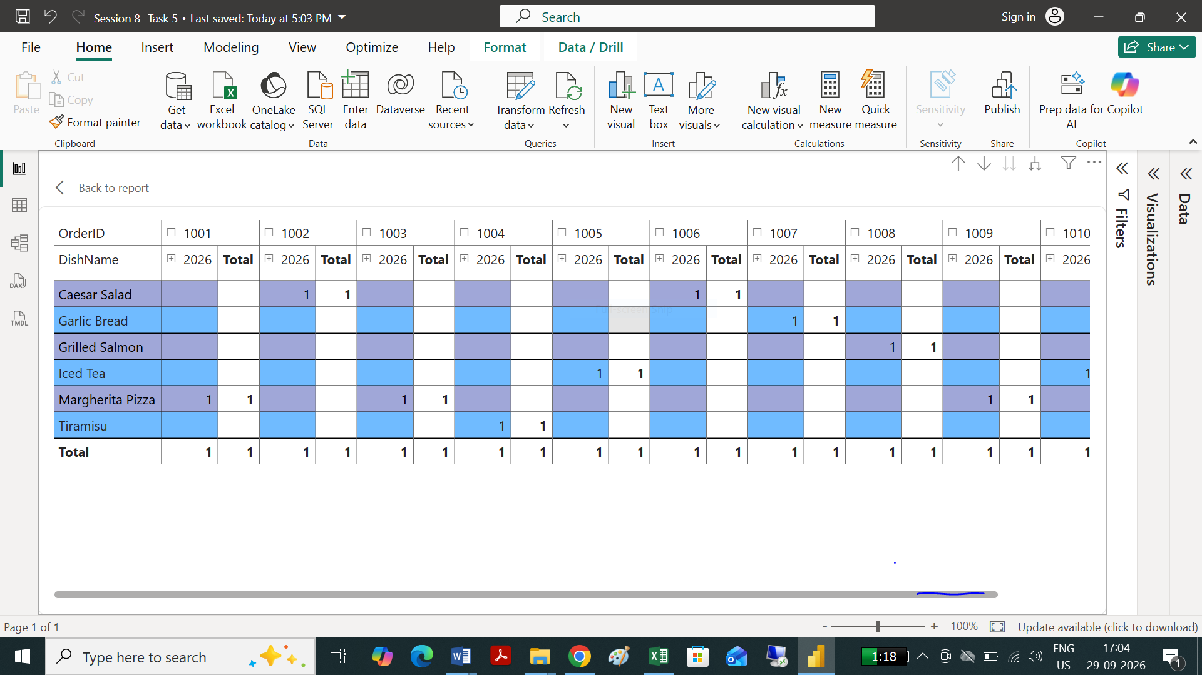

# Session 9:
Task 1:
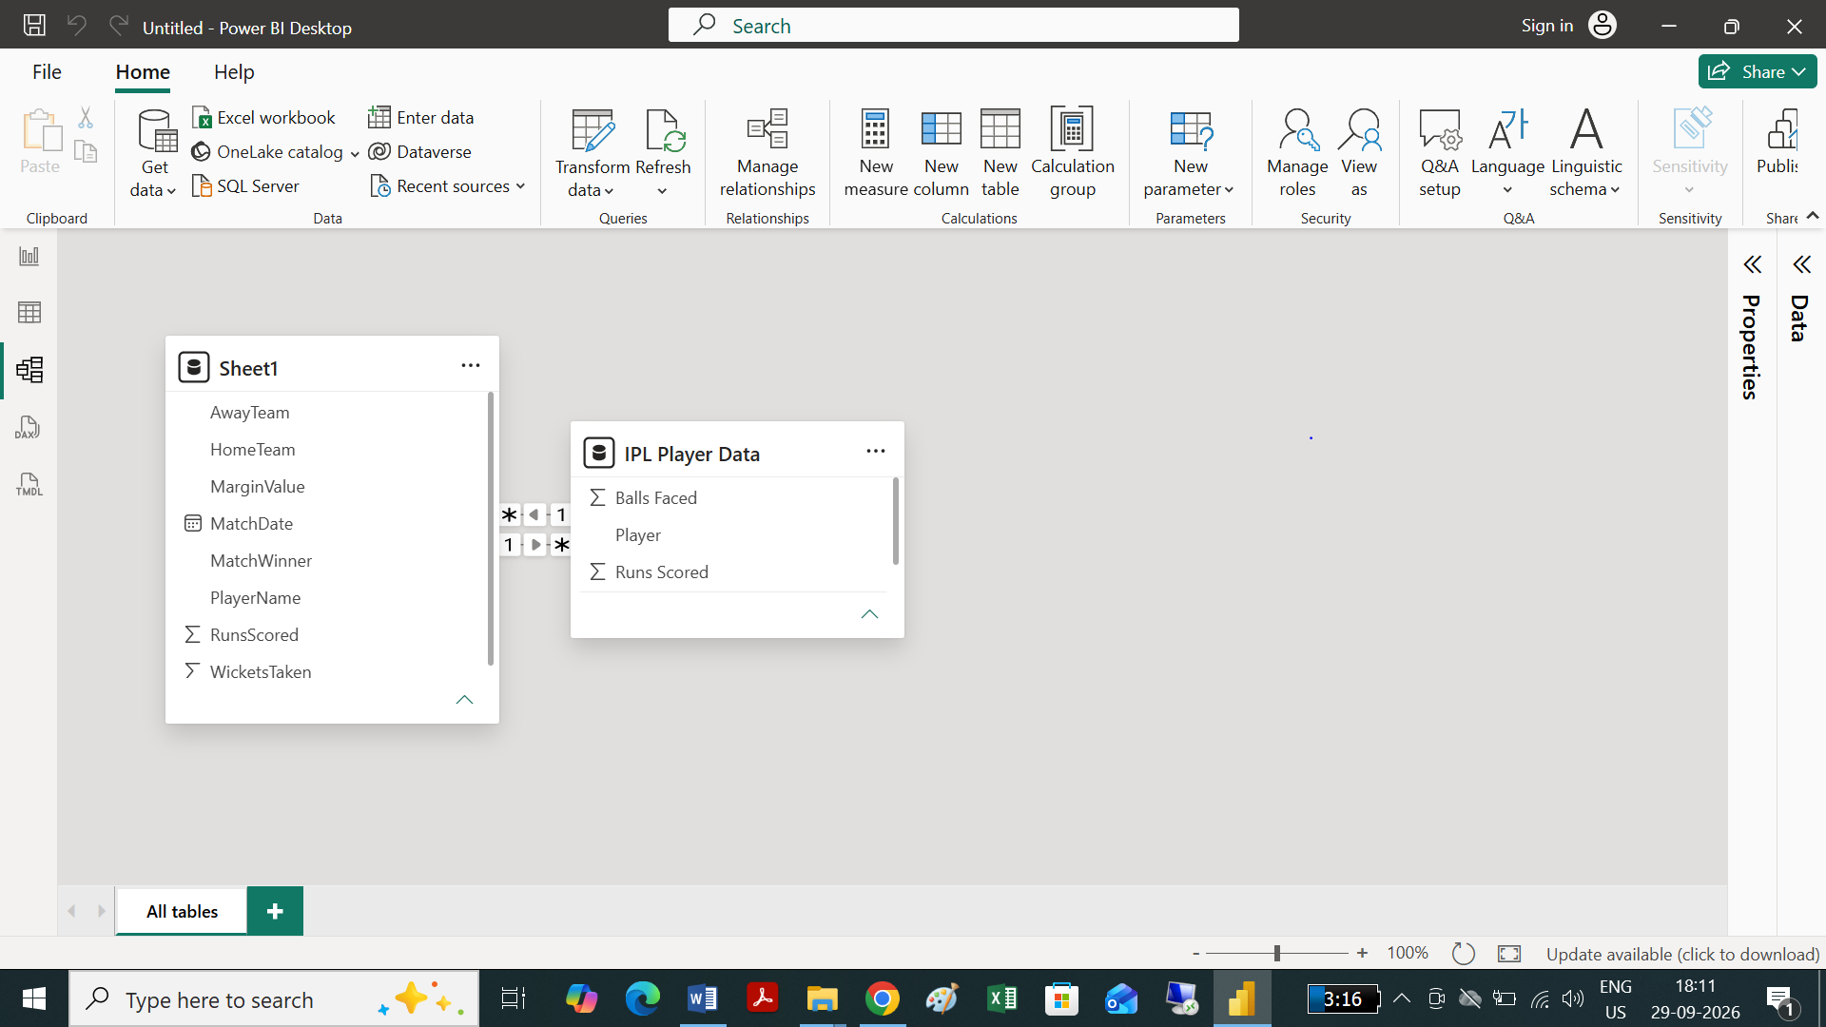

Explanation of Inactive Relationships in Sports Analytics
Why Inactive Relationships are Essential in Sports Analytics:
- Handling Role-Based / Multiple Foreign Keys (Role-Playing Dimensions): A single cricket match inherently involves a team in multiple roles—as the Home Team, Away Team, or Winning Team. Power BI only allows one active relationship path between two tables at a time to prevent circular references and ambiguous filter contexts.
- Flexible & Dynamic Measure Calculations: By keeping additional relationships (like Teams[Team_ID] ↔ Matches[Away_Team_ID]) inactive, you preserve the integrity of the data model while retaining full analytical capability. You can dynamically activate the secondary relationship inside specific DAX measures using the USERELATIONSHIP() function to compute metrics such as:
  - Home vs. Away Performance Split: Easily compare home wins vs. away wins without duplicating the Teams table.
  - Head-to-Head & Match Analysis: Filter performance metrics depending on whether the team was batting first, chasing, playing at home, or away.

Task 2:
Here is how this change affects your report when you select a specific match:

1. The Core Effect (Bi-Directional Filtering)
- Under 'Single' Direction: The relationship typically filters in one direction—usually from the dimension table to the fact table, or along the direction of the arrow (e.g., Players → Matches or vice versa). Selecting a match only filters tables downstream from Matches.
- Under 'Both' Direction: The filter context now flows in both directions. Selecting a match in your report filters the Matches table, which in turn filters the Players table, which then propagates down to filter any related tables like Player Stats (or performance metrics).

2. What You Observe in Your Report
When you select or slice by a specific match (e.g., Match ID: 101):
- Filtered Player List: The Players table is automatically reduced to only show the players who participated in that specific match. Unrelated players are filtered out.
- Contextual Player Stats: Visuals, tables, or cards displaying player statistics (e.g., goals scored, total passes, minutes played, or points) will automatically calculate metrics strictly for that specific match for the filtered subset of players.
- Slicer Interactivity: If you have a player dropdown/slicer on the report page alongside a match slicer, selecting a match will immediately shrink the player slicer options so it only displays players relevant to that match.

💡 Things to Keep in Mind
- Ambiguity and Performance: While setting cross-filter direction to "Both" provides intuitive filtering across related entities, using bi-directional filtering across multiple tables can lead to ambiguous model paths or slower report performance in large models.
- Alternative Approach: In production models, DAX functions like CROSSFILTER() inside a measure or using bridge/fact-table filters are often preferred over setting the model-level relationship to "Both."
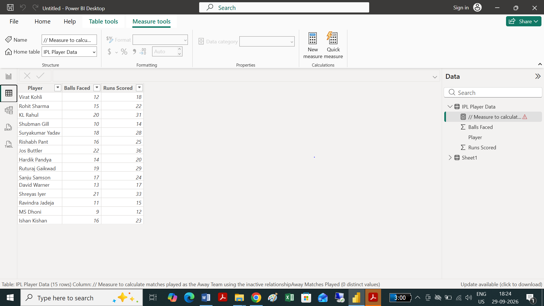

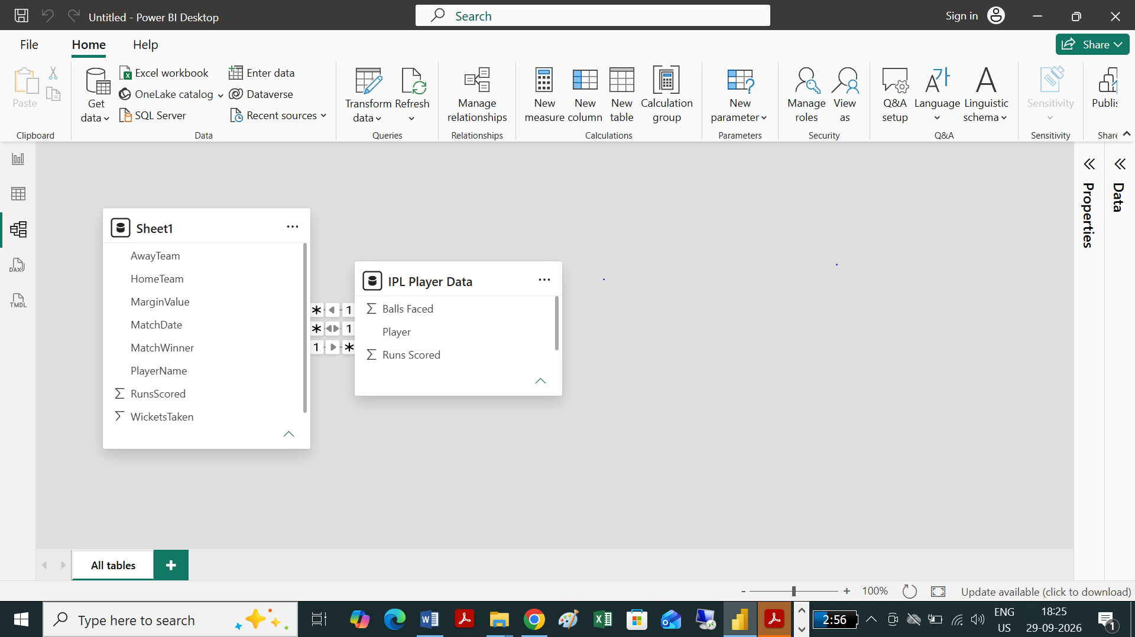

Task 3: Home team and Player name team is hided
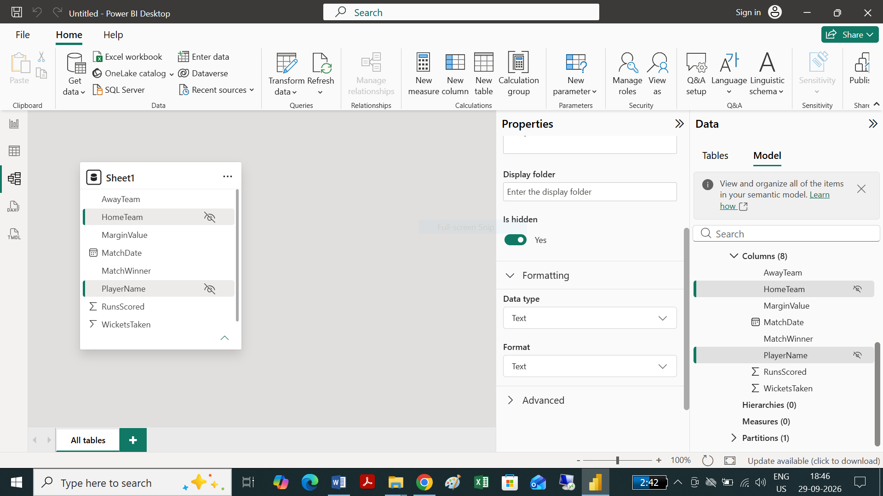

Key Notes & Security Considerations
- Visual Verification: Hidden fields will appear grayed out in Power BI Desktop's Data pane to remind you they are hidden, but they will be completely invisible to report viewers once published to the Power BI Service.
- Calculations: Measures and DAX expressions will still be able to reference PlayerEmail or PlayerPhone in the background even when they are hidden from the user interface.
- Important Security Note: Hiding a column in Report View hides it from the UI, but it does not secure the data. Users with permission to download the .pbix file or connect via Analyze in Excel can still access hidden columns. If you need true security to restrict access to PII (Personally Identifiable Information), implement Row-Level Security (RLS) or remove the columns in Power Query before loading the data model.
Task 4:

Key Behavioral Differences: Calculated Columns vs. Measures
Feature | Calculated Column (Match Category) | Measure (Average Runs Per Match)
Evaluation Context | Row Context: Evaluated line-by-line during data refresh. | Filter Context: Evaluated dynamically based on active visual filters, slicers, or user interactions.
Storage & RAM | Stored directly in the Data Model, consuming disk space and RAM memory. | Not stored in memory; calculated on-the-fly when added to a visual or report.
Usage in Visuals | Ideal for slice-and-dice operations (Slicers, Row/Column Headers, Axis categories). | Ideal for numerical values, aggregations, KPIs, tooltips, and data cards.
Reactivity | Static; does not react dynamically to slicers or report interactions. | Dynamic; automatically updates value whenever filters or slicers change.
Task 5:
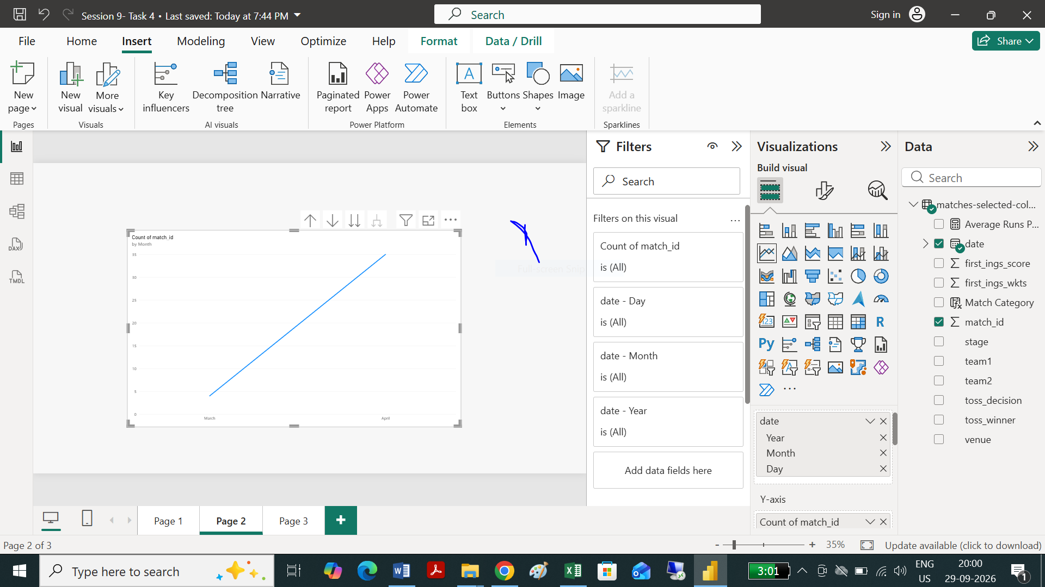
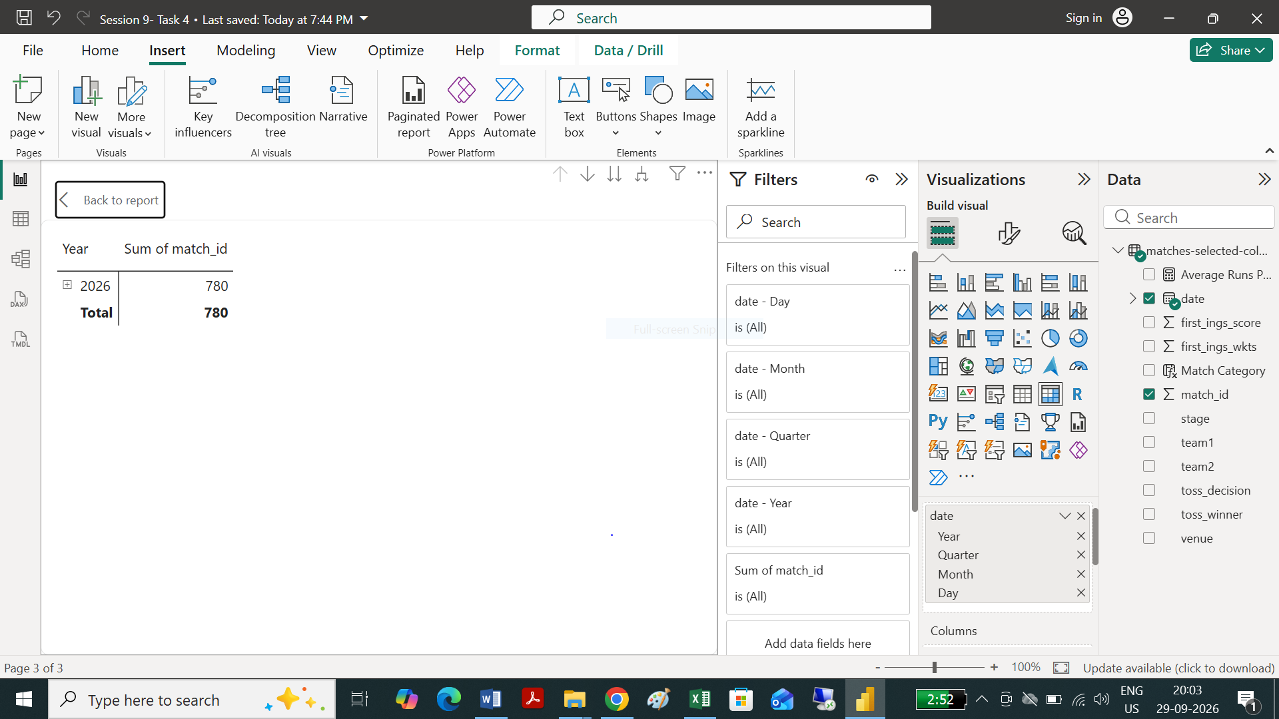
Session 10:
Task 1:
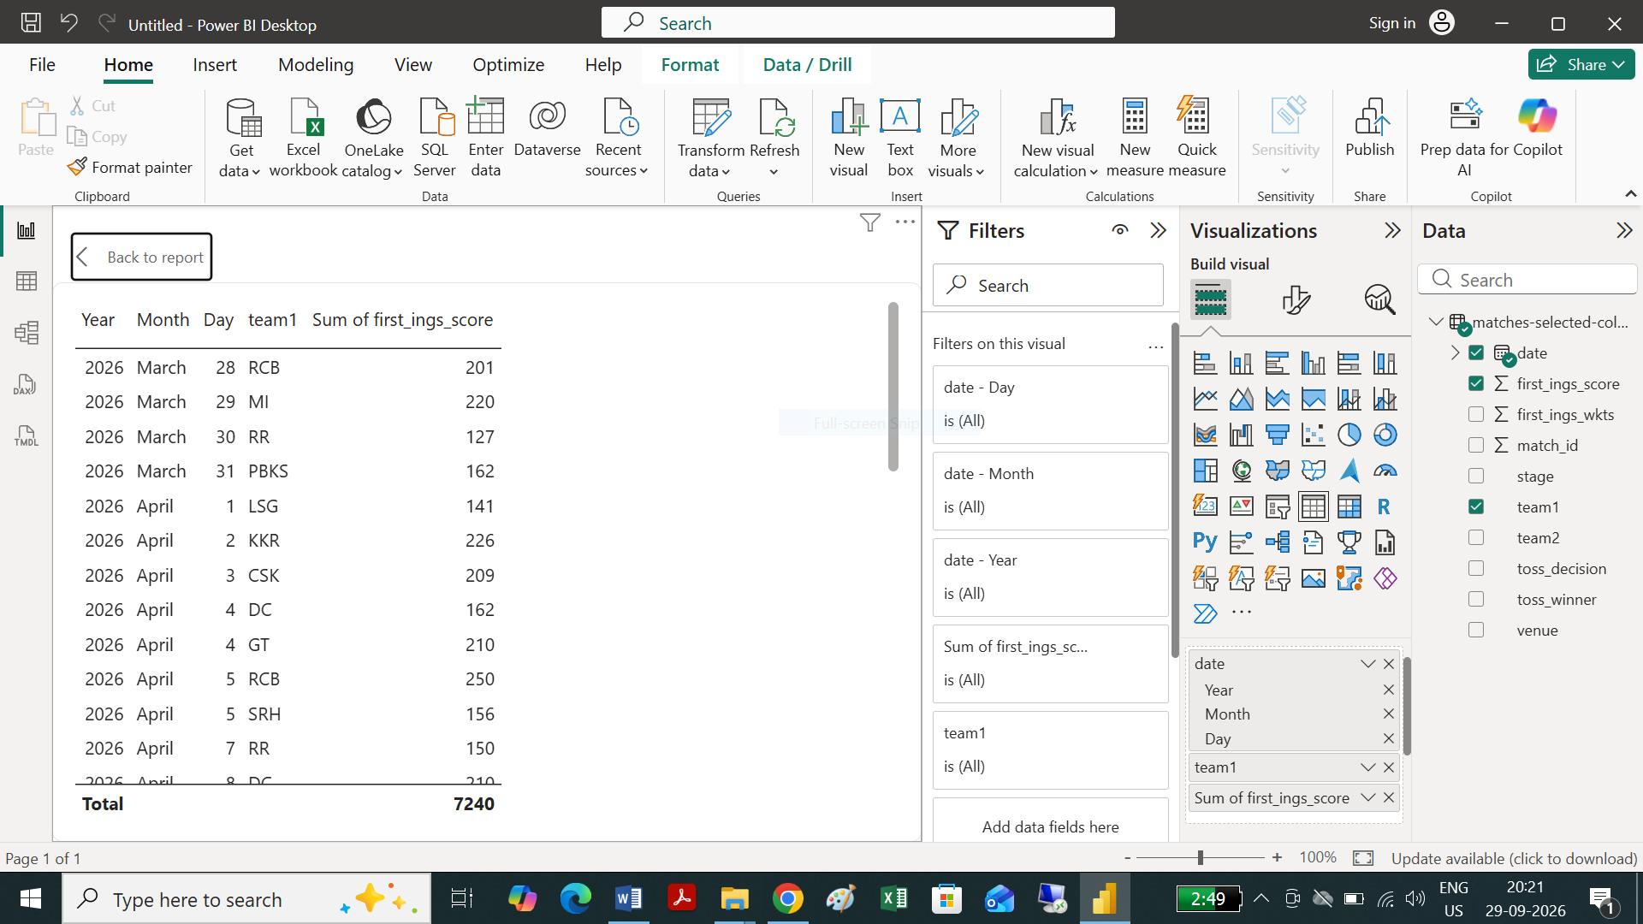
Task 2:
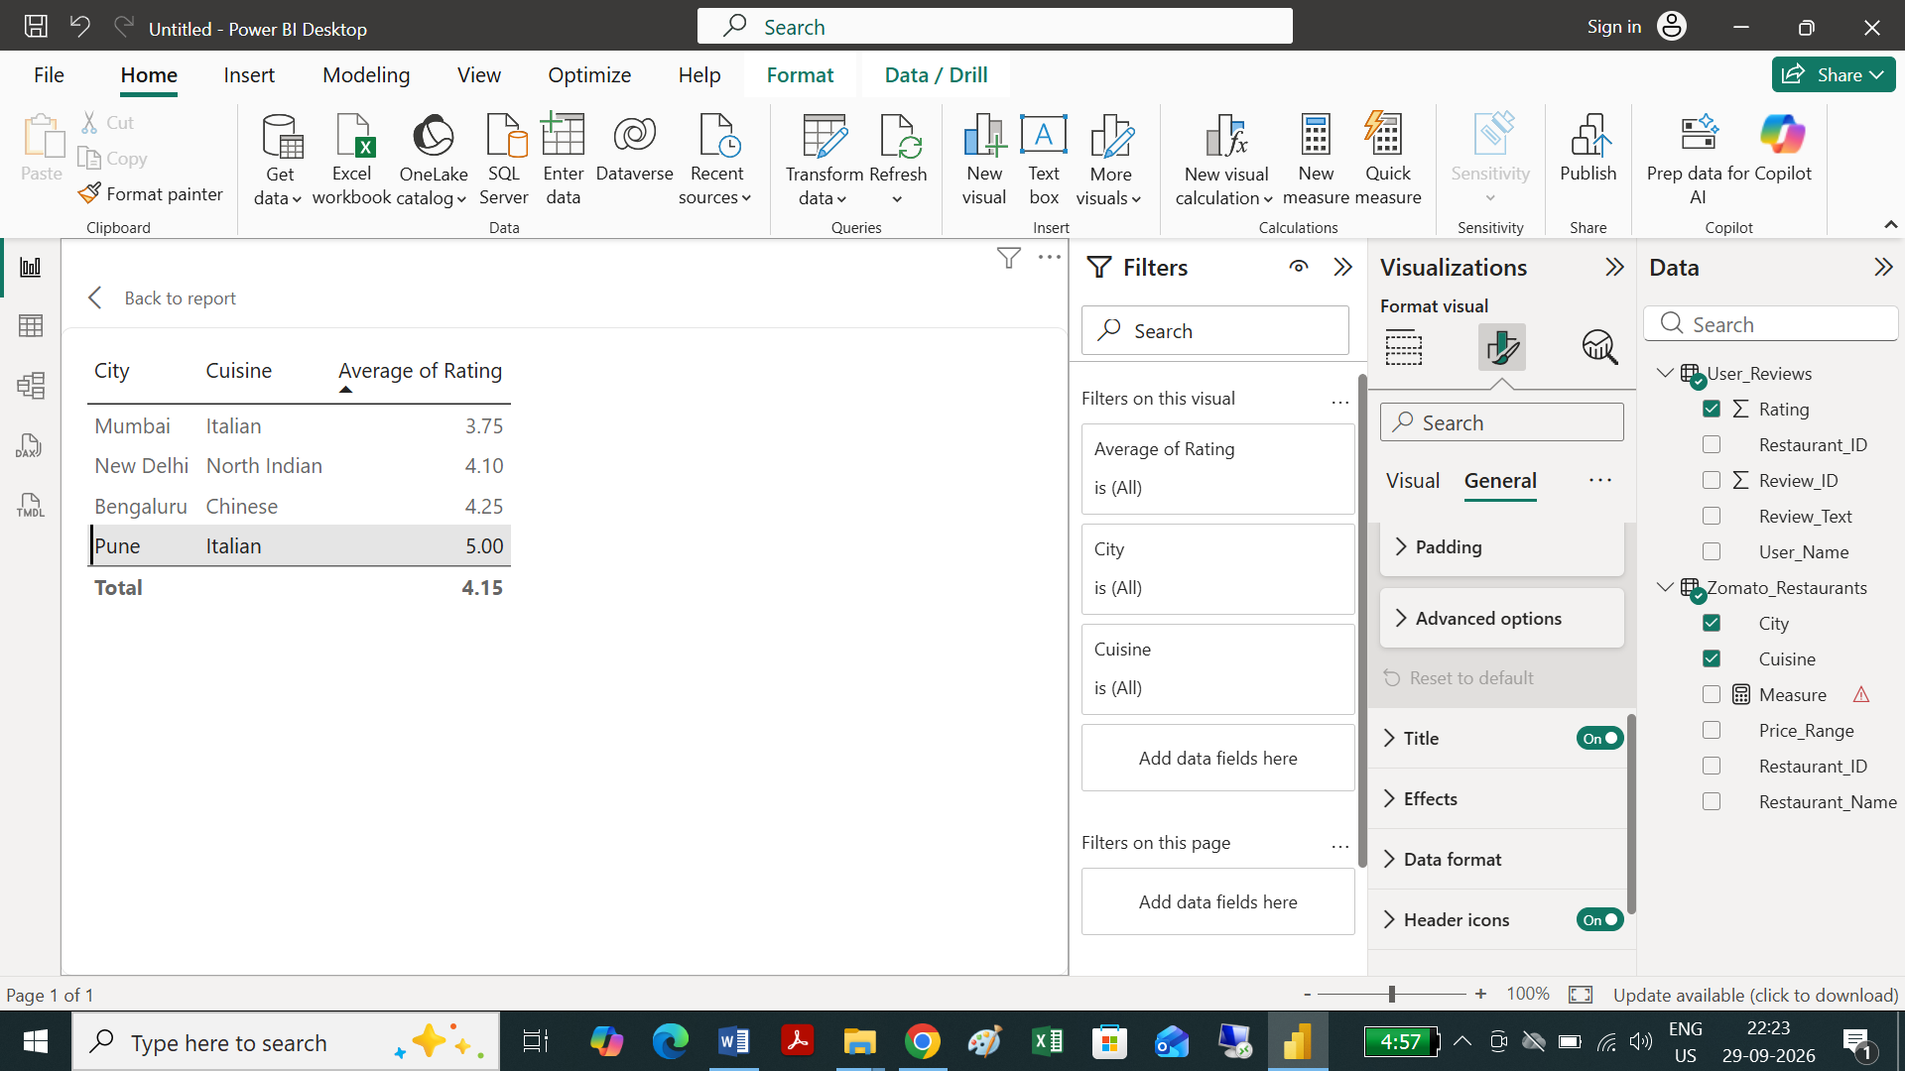

Task 3:
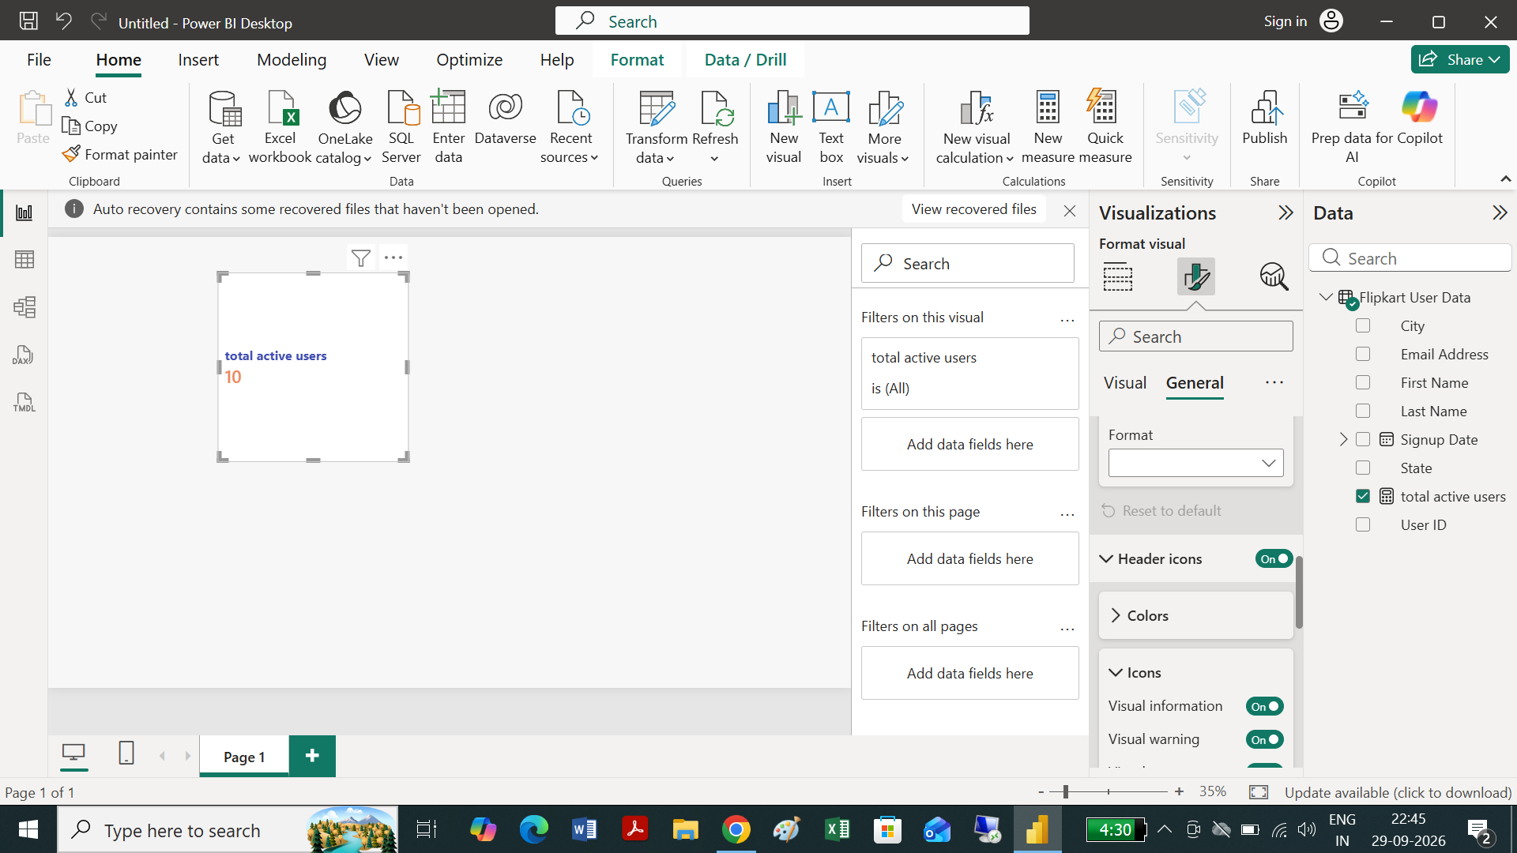

Task 4:
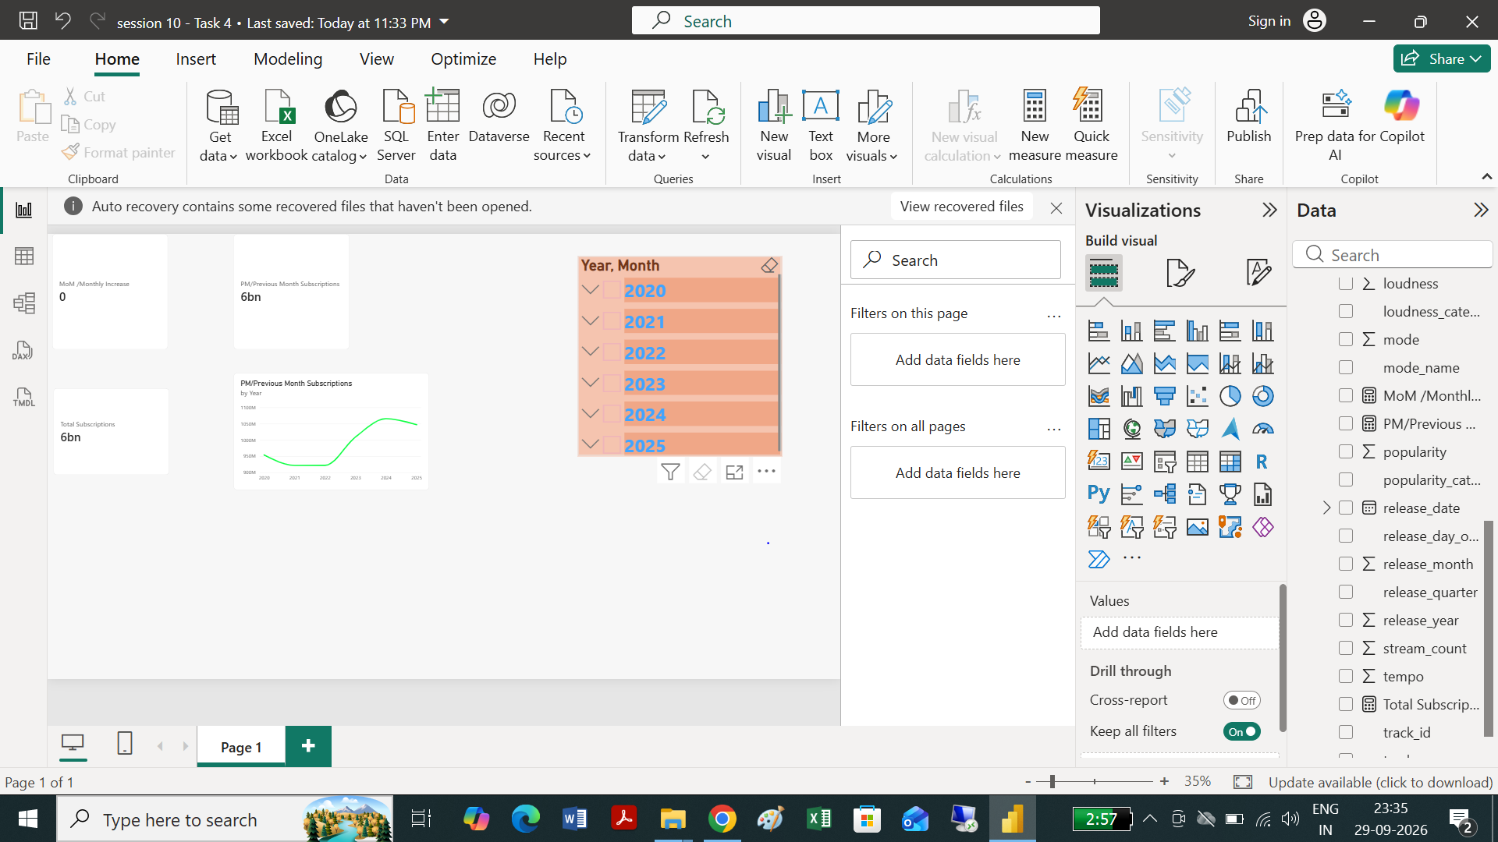

Task 5:
